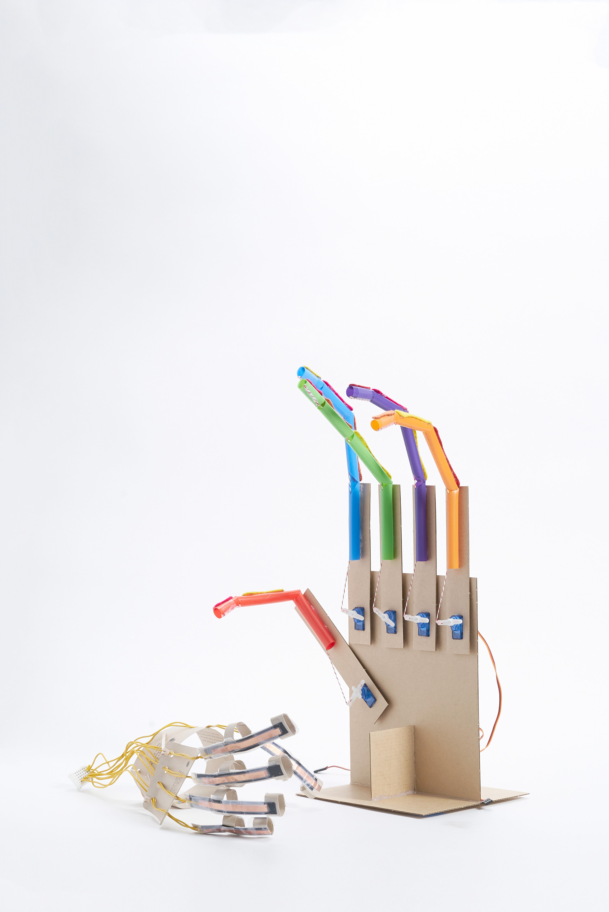



Lesson plan and more resources are

available at: https://aka.ms/robotic-hand

**ROBOTIC HAND**

Building machines that   
emulate humans

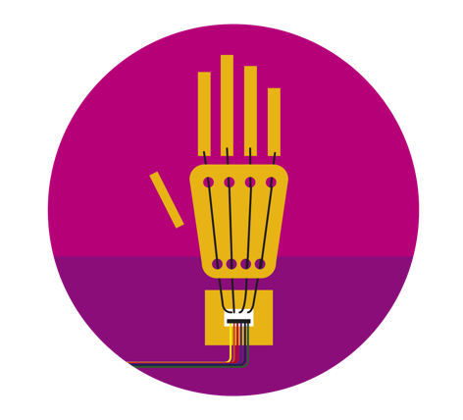

Build and learn

You will build a sensor that measures flexion and extension to learn about tracking the movement of a human finger. Next, you will assemble a cardboard glove and attach multiple sensors to visualize how bones work within the skeletal system.

Connect your tools

You will connect their sensor-enabled glove (and/or finger) to the Excel workbook via an Arduino Uno microcontroller. Utilizing the graphics in Excel, you will determine the flexion of fingers when contracted.

Visualize the data

You will run trials with the sensor-enabled glove and robotic hand to generate ideas to improve the range of tasks it can accomplish. Using a customized Excel workbook, you can see real-time data input and analyze it.

Contents

**02** Activity Overview

**04** Materials:Single finger

**05** Materials:Full hand

**06**  Flex Sensor

**19** Articulated Finger

**32** Glove Controller

**46** Robotic Hand

**61** Appendix I: Software

**65** Appendix II: Troubleshooting

**66** Appendix III: Project Extensions

**67** Appendix IV: Templates

Hack our projects

We love innovation and encourage you to hack our projects and make them your own. Submit your ideas at aka.ms/hackingstem.

v

Activity overview

This activity integrates life science with robotics, while incorporating crucial 21st century technical skills like data science, software, mechanical and electrical engineering, for an authentic learning experience. Emphasis is placed on the importance of combining science and technology to reflect the mechanics of the human body.

View the full lesson plans mapped to NGSS and ISTE standards, materials and activities to support this unit at [https://aka.ms/robotic-hand.](https://aka.ms/robotic-hand)

Please note that lesson activities will require adult supervision.

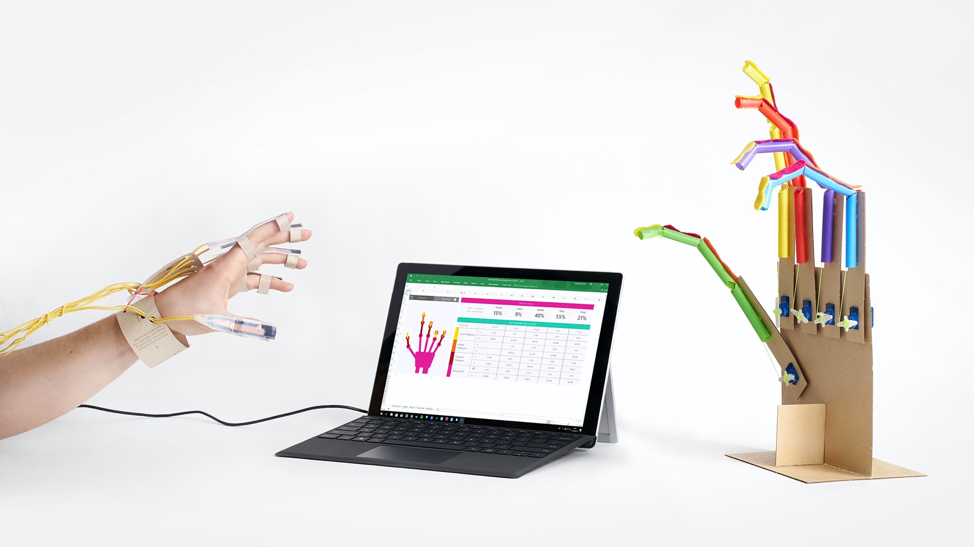

How to use this document

These instructions detail how to build a glove controller with five finger flex sensors to control a robotic hand in the physical world as well as a simulated hand in Microsoft Excel. You have the option of building the whole project or choosing parts that fit your learning goals and interests. We recommend using these instructions to complete any of the following projects:

**Option 1:** Build one finger flex sensor and connect it to a single articulated finger

* Use material list on page 4
* Use instructions on pages 6 for the finger sensor
* Use instructions on pages 19 for the articulated finger

**Option 2:** Build the whole hand

* Use material list on page 5
* Use instructions on all pages. We recommend building the robotic hand in the following order:
  1. Finger flex sensors
  2. Articulated fingers
  3. Glove controller
  4. Robotic hand

**Option 3:** Choose your own adventure

While we offer 2 different paths to build this this project, you are free to pick and choose any part of these instructions to build your own project.

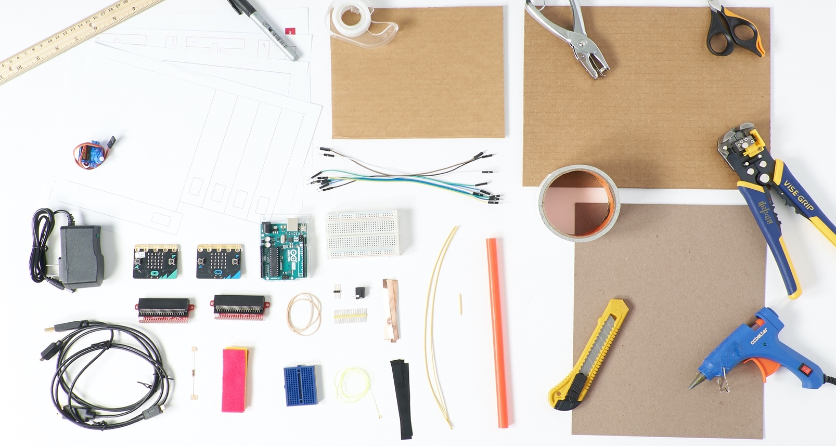

Materials and Tools: Single Finger

Use this material list if you are building only one (1) articulated finger and only one (1) flex sensor. A detailed list for each section is included at the start of each section.

**Finger Sensor**

1 sheet of cardstock

4 strips copper tape, 0.5 cm x 7 cm

2 strips of Velostat ,1 cm x 8 cm

2 solid core wire, 30 cm x 20 awg

1 hand template (pg. 70, 72)

**Articulated Finger**

1 milkshake or Boba straw

50 cm braided dacron kite thread, or fishing line

4 felt, 2.5 cm x 7.5 cm

4 bone labels

1 straw and felt template (pg. 68)

Optional: 1 large rubber band

**Finger Tester**

1 servo motor

5 male-to-male jumper wires

1 100-ohm resistor

3 pin male breakaway headers

1 5V power supply

1 barrel jack breadboard adapter

2 chipboard or heavyweight cardstock, 22 cm x 28 cm

1 robotic hand template (pg. 74, 76)

**Arduino Uno**

1 half-size breadboard

1 mini breadboard

1 Arduino Uno

1 USB cable A-to-B (for Arduino)

**OR**

**micro:bit**

2 half-size breadboards

2 micro:bits

2 edge connectors

2 microUSB cables

**Toolkit**

scissors

clear tape

wire strippers

single hole punch

utility knife

duct tape

hot melt tool

permanent marker

**Making for a group or need help finding materials?**

View the shopping list to calculate quantities and links to materials at: aka.ms/robotichandshoppinglist.

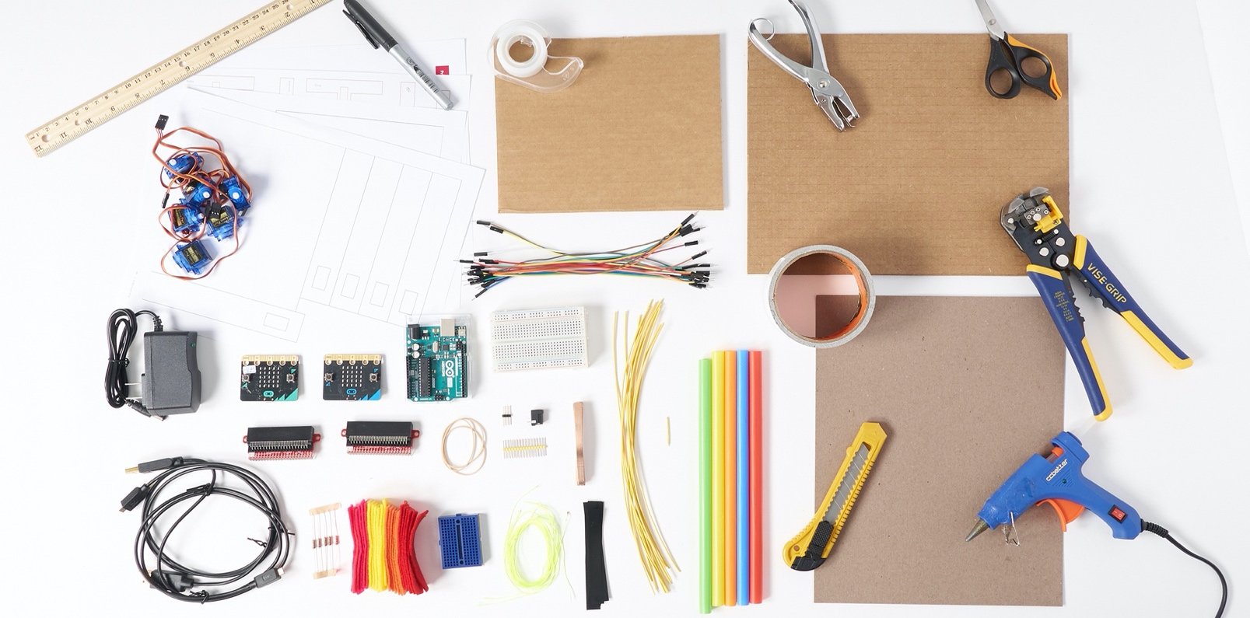

Materials and Tools: Robotic Hand

Use this material list if you are building the whole robotic hand and glove controller.

**Finger Sensors**

1 sheet of cardstock

1 carboard, roughly 20 cm x 16 cm

20 strips copper tape, 0.5 cm x 7 cm

10 strips of Velostat, 1 cm x 8 cm

10 solid core wire, 22 awg x 30 cm

1 solid core wire, 22 awg x 2 cm

1 hand template (pg. 70, 72)

**Glove Controller**

12 male-to-male jumper wires

5 100-ohm resistor

3 rubber bands size #16

**Articulated Fingers**

5 milkshake or Boba straw

5 50 cm braided dacron kite thread, or fishing line

20 felt, 2.5 cm x 7.5 cm

20 bone labels

1 straw and felt template (pg. 68)

Optional: 2 large rubber bands

**Robotic Hand**

5 servo motors with arms

17 male-to-male jumper wires

15 pin male breakaway headers

1 5V power supply

1 barrel jack breadboard adapter

2 chipboard or heavyweight cardstock, 22 cm x 28 cm

1 robotic hand template (pg. 74, 76)

**Arduino Uno**

1 half-size breadboard

1 mini breadboard

1 Arduino Uno

1 USB cable A-to-B (for Arduino)

**OR**

**micro:bit**

2 half-size breadboards

2 micro:bits

2 edge connectors

2 micro USB cables

**Toolkit**

scissors

clear tape

wire strippers

single hole punch

utility knife

duct tape

hot melt tool

permanent marker

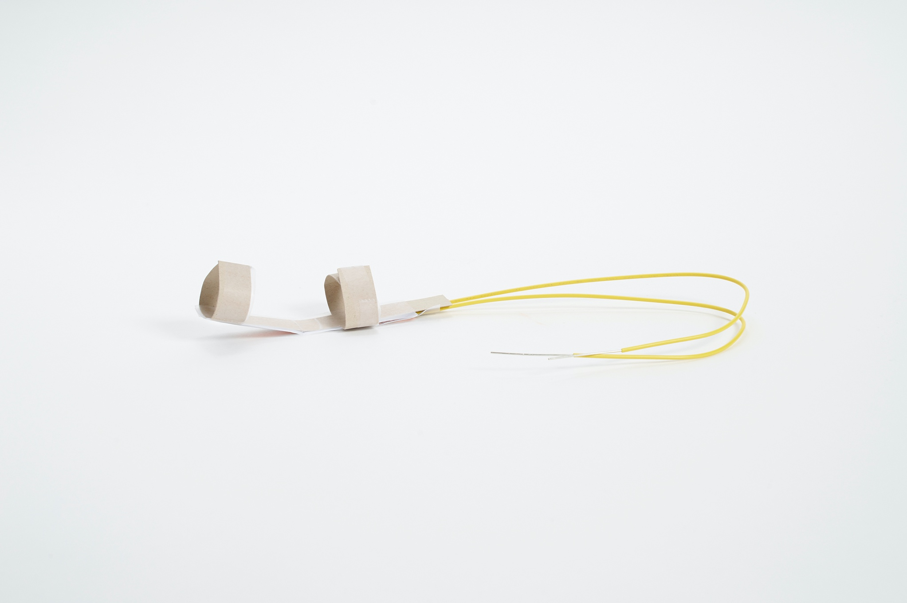

**ROBOTIC HAND**

Flex sensor

Lesson plan and more resources are available at: [https://aka.ms/robotic-hand.](https://aka.ms/robotic-hand)

|  |
| --- |
|  |

Things you’ll need to build a flex sensor

**Finger Sensor**

1 sheet of cardstock

4 strips copper tape 0.5 cm x 7 cm

2 strips of Velostat 1 cm x 8 cm

2 solid core wire 30 cm x 20 awg

5 male-to-male jumper wires for microcontroller

1 100-ohm resistor

1 hand template (pg 70, 72)

**Arduino Uno**

1 half-size breadboard

1 mini breadboard

1 Arduino Uno

1 USB cable A-to-B (for Arduino)

**OR**

**micro:bit**

1 half-size breadboard

1 micro:bit

1 edge connector

1 microUSB cable

**Toolkit**

ruler

scissors

clear tape

wire strippers

***Safety guidelines***

***Hot Melt Tool***

* *Place it on a level surface to avoid tipping over.*
* *Place the electrical cable out of the way to avoid a tripping hazard.*
* *Do not touch the tip of the tool or the hot glue coming out of it.*

***Eye Protection***

* *Please wear appropriate eye protection while doing any engineering design or field projects.*

***Cutting Tools***

* *Keep the sharp edge away from your body.*
* *Always cover the blade with a plastic cap when not in use.*
* *When cutting small pieces, do not place fingers very closed to the blades.*

***Wire Strippers***

* *Always keep your fingers and hands out of the cutting area.*

**Making for a group or need help finding materials?**

View the shopping list to calculate quantities and links to materials at: aka.ms/robotichandshoppinglist.

Make a guide for sensor building

|  |  |  |
| --- | --- | --- |
|  |  |  |
| **1** | A simple U-shaped guide will make sensor building easier. Cut a piece of cardboard to roughly 20 cm x 16 cm. Next, cut out a notch 3.5 cm deep and 11 cm long. |  | **2** | Wrap the resulting tabs with tape, this will provide you with a base that has a non-stick surface to build sensor layers. Set your U-shaped guide aside, you will use it later. |
|  |  |  |
|  |  |  |
| **3** | Select and print a template based on your hand size (page 70, 72). Print at 100% with no scaling. Using your scissors and utility knife, cut out just the **Index Finger** from the template and trace your pattern onto cardstock. Keep the templates as a guide for placing copper tape and wires later. |  | **4** | Cut out the traced cardstock **Index Finger** and label it**.** |
|  |  |  |
|  |  |  |
|  |  |  |

Make the flex sensor

|  |  |  |
| --- | --- | --- |
|  |  |  |
|  |  |  |
| **1 |** Grab your materials for your finger sensor. This includes the finger splint, 4 strips of copper tape, 2 strips of velostat, 2 strips of wire, tape, and wire strippers. |  | **2 | For both flex sensor wires**, remove 2 cm of the plastic coating from the end of the wire. |
|  |  |  |
|  |  |  |
| **3 |** For each wire**,** bend the exposed metal end. |  | **4 |** Place a piece of adhesive tape, **sticky-side down**, over the entire length of the Index finger splint. This is your base layer. |
|  |  |  |
|  |  |  |

|  |  |  |
| --- | --- | --- |
|  |  |  |
| **5 |** Flip over your splint and remove the backing from one strip of copper tape. Adhere the sticky-side to the center of the splint. |  | **6 |** Grab your first wire and place the wire loop at the end of the copper tape. |
|  |  |  |
|  |  |  |
| **7** | Peel the backing from a second strip of copper tape and attach it directly over the first wire loop. |  | **8** | Press firmly to seal the wire loop between the two copper strips. Avoid bends and folds in the copper tape. ***Pro Tip:*** *Wrap clear tape around the end of the splint to secure the wire to the splint leaving the rest of the copper tape uncovered.* |
|  |  |  |
|  |  |  |
| **9** | The first half of your sensor should look like this. |  | These are the sensor layers you have completed so far. Good job! |

|  |  |  |
| --- | --- | --- |
|  |  |  |
| **10 |** The U-shaped guide will help you build the second half of the sensor. Place a piece of clear tape between the two tabs. |  | **11 |** Flip your guide over so that the clear tape is **sticky-side up.** Grab a piece of copper tape and place it on the clear tape **with the removable backing facing up**. |
|  |  |  |
|  |  |  |
| **12 |** Fully remove the backing on the copper tape. |  | **13 |** Place your second wire on top of the copper tape as before. |

|  |  |  |
| --- | --- | --- |
|  |  |  |
|  |  |  |
| **14 |** Remove the backing from another piece of copper tap and place it **sticky-side down,** pressing firmly to secure a good electrical connection. Set aside for now. |  | **15 |** Grab your finger splint. Take two strips of Velostat and place both directly over the base layer of the sensor. |
|  |  |  |
|  |  |  |
| **16 |** Your finger splint should look like the photo above. |  | **17 |** Now take your U-shaped guide with the copper tape and wire and flip it over to attach it directly on top of the finger splint, encasing the Velostat strips. |

|  |  |  |
| --- | --- | --- |
|  |  |  |
| **18 |** Snip the tape from the top and bottom edges of the finger splint to remove it from the U-shaped guide. |  | **19 |** Check your sensor layers using the guide to the right.  ***Pro Tip:*** *wrap clear tape around the end of the splint to secure the wires to the splint and keep the connection tight.* |
|  |  |  |
|  |  |  |
| These are the layers you have completed. Great job! |  | **20 |** Take a piece of clear tape and cut it down the middle. You will need both halves. |
|  |  |  |
|  |  |  |
| **21 |** Place your half strips of tape over the cardboard tabs as shown in the picture above. |  | **22 |** Fold your tabs closed and tape the edges together so that the sensor layers are on the side opposite the finger slots. |
|  |  |  |
| **23 |** Try on your flex sensor to make sure it fits and flexes with your finger movement. |  | **24 |** Remove 0.5 cm of coating from the loose ends of all sensor wires. |

|  |  |
| --- | --- |
|  |  |
| Machine generated alternative text: |  |
| **25 | Building the whole glove?** Go to page 8-13 and then repeat steps1 – 27 to create four (4) more flex finger sensors. Otherwise skip to the next section to wire up your flex sensor.  ***Note****: if working in a group, each group member should build a sensor.* |  |

Connect flex sensor to Arduino Uno

**If you using a micro:bit microcontroller board skip to the next page.**

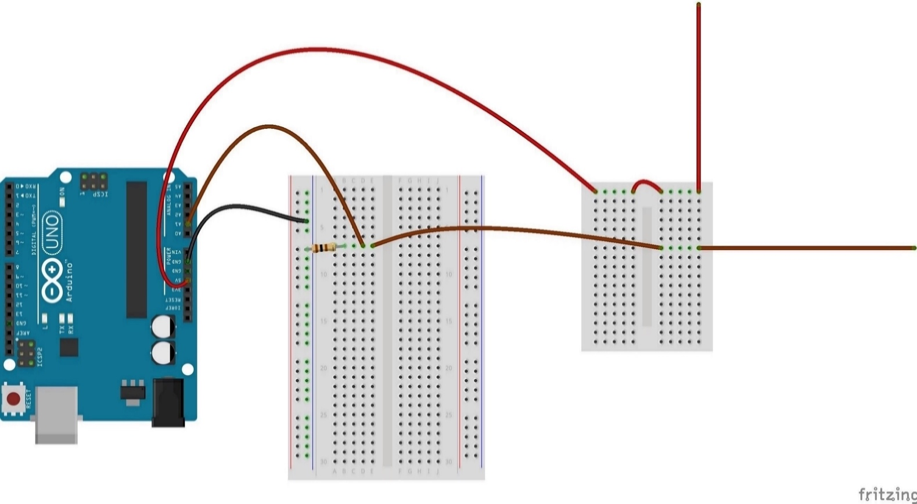

**Index 2**

**Index 1**

|  |  |  |
| --- | --- | --- |
| **1 |** Flash your Arduino Uno with the project code as shown in Appendix I: Software. |  | **2 |** Insert both of your flex sensor wires into two different rows of the mini breadboard, with one of the wires in the topmost row. |
| **3 |** On the mini breadboard, connect a jumper wire across the trench to connect the two topmost rows, as shown in the diagram. |  | **4 |** Connect your jumper wire from the Arduino **5V** power supply pin to the topmost mini breadboard row, as shown in the diagram. |
| **5 |** Connect your next jumper wire from the Arduino **GND** pin to the negative power rail on the half-size breadboard. |  | **6 |** Connect your next jumper wire between the second flex sensor wire and an open row on the half-size breadboard. |
| **7 |** On the half-size breadboard, connect your 100-ohm resistor between the second flex sensor wire and the negative power rail.  ***Note****: Orientation of the resistor does not matter.* |  | **8 |** Connect your next jumper wire between the second flex sensor wire and the resistor to the Arduino analog pin **A1** as shown on the diagram. |

Circuit images made with Fritzing and are licensed for use under CC by SA 3.0. See <http://creativecommons.org/licenses/by-sa/3.0/> for the full description.

Connect flex sensor to micro:bit

If you are using an Arduino microcontroller board skip this page.

|  |  |  |
| --- | --- | --- |
|  |  |  |
| **1 |** Grab your **first** set of micro:bit materials: micro:bit, edge connector, half-size breadboard, micro USB Cable. Label this micro:bit “Flex Sensor”. |  | **2 |** Connect your flex sensor micro:bit into the computer with the microUSB cable and load the Flex Sensor code onto the micro:bit as shown in Appendix I: Software. |
| Machine generated alternative text: |  |  |
| **3 |** Insert the micro:bit edge connector into the breadboard. |  | **4 |** Plug the micro:bit into the edge connector. |

Connect flex sensor to micro:bit

If you are using an Arduino microcontroller board, skip this page.

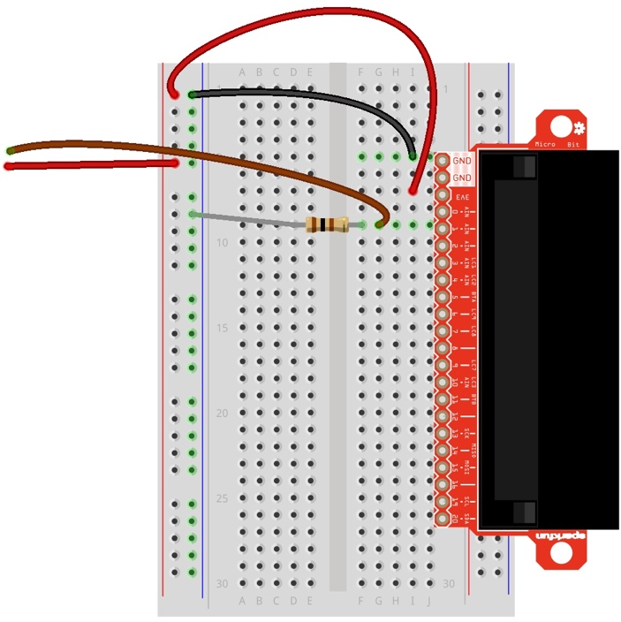

|  |  |  |
| --- | --- | --- |
| **1 |** Connect your first jumper wire from the micro:bit **3V** power supply in to the breadboard positive power rail. |  | **2 |** Connect your second jumper wire from the micro:bit **GND** pin to the negative power rail. |
| **3 |** Connect your first flex sensor wire to the breadboard positive power rail. |  | **4 |** Connect your second flex sensor wire to the micro:bit inputpin **1.** |
| **5 |** Connect your 100-ohm resistor between the second flex sensor wire and the breadboard negative power rail, as shown in the diagram above.  ***Note****: Orientation of the resistor does not matter.* |  |  |

Circuit images made with Fritzing and are licensed for use under CC by SA 3.0. See <http://creativecommons.org/licenses/by-sa/3.0/> for the full description.

Excel Workbook Overview

To run the full project, make sure you meet these technical requirements:

* PC running Windows 10 and Excel O365 Desktop.
* Enable the Data Streamer add-in. See instructions in Appendix 1.
* Customized Excel Workbook available at: aka.ms/biomechanicsworkbook.

This chart shows the amount of flexion your finger exerts when contracted

Choose the radio button for the hand you are using to control the robotic finger

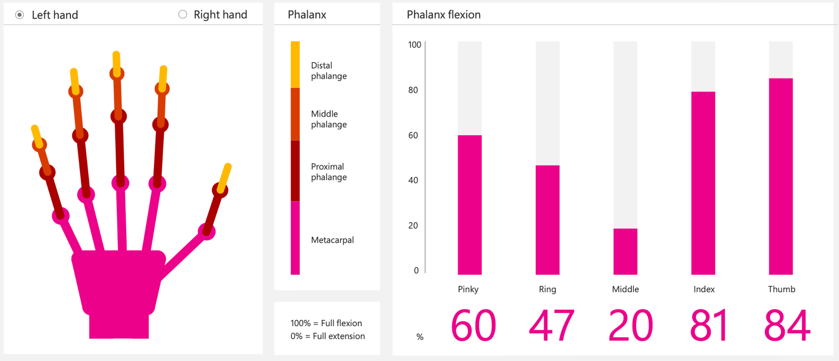

Test the flex sensor



|  |  |  |
| --- | --- | --- |
| **1 |** Test that the flex sensor functions correctly by connecting your microcontroller to your computer via USB and opening the Excel workbook. |  | **2 |** Start data collection and then move the flex sensor. If everything is working properly, you will see the corresponding finger in the workbook move as you move the flex sensor.  ***Note:*** *unconnected fingers may appear to be moving due to random signals from the microcontroller – neglect this until all sensors are connected.* |

**TROUBLESHOOTING**

If your flex sensor doesn’t work, follow this troubleshooting process.

**Problem:** The corresponding finger in the Excel simulation does not move or moves randomly.

**Possible Solutions**:

* Check that the microcontroller is plugged in and the code successfully uploaded to the board.
* The sensor readings take some time to settle. Wait for a few seconds and then retry.
* Double check your sensor connections to the microcontroller.
  + Arduino: The index finger connects to analog pin A1.
  + micro:bit: The index finger connects to pin 1.
* The sensor could be faulty in the glove. If so, remove and replace or acquire one that's working to check that the leads are properly connected.
* Make sure that you're using the correct Excel Workbook—each Hacking STEM project comes with its own customized workbook.

*Still not working? Ask a classmate, your teacher, or reach out to us at: aka.ms/hackingSTEM.*

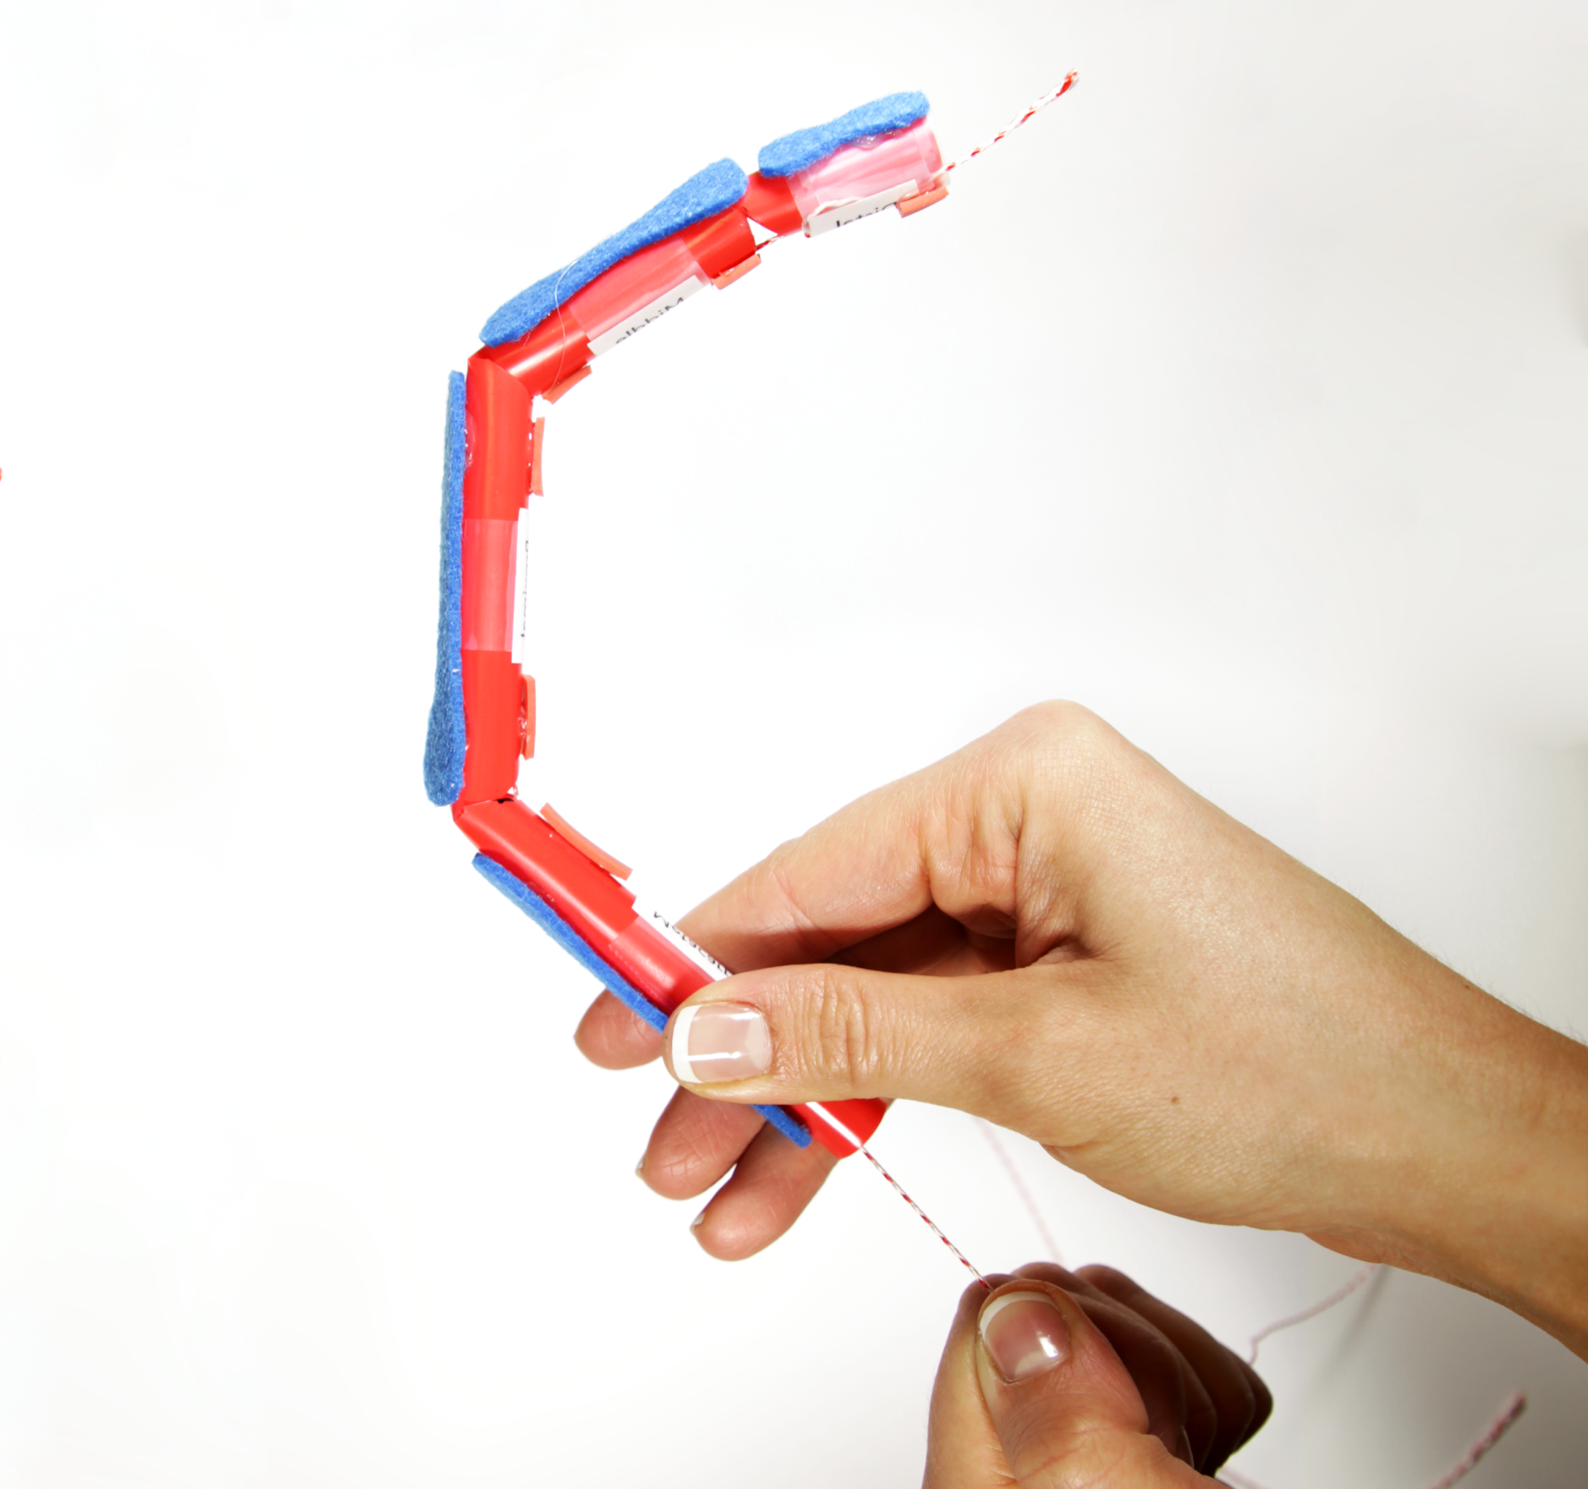

**ROBOTIC HAND**

Articulated finger

Lesson plan and more resources are available at: <https://aka.ms/robotic-hand>

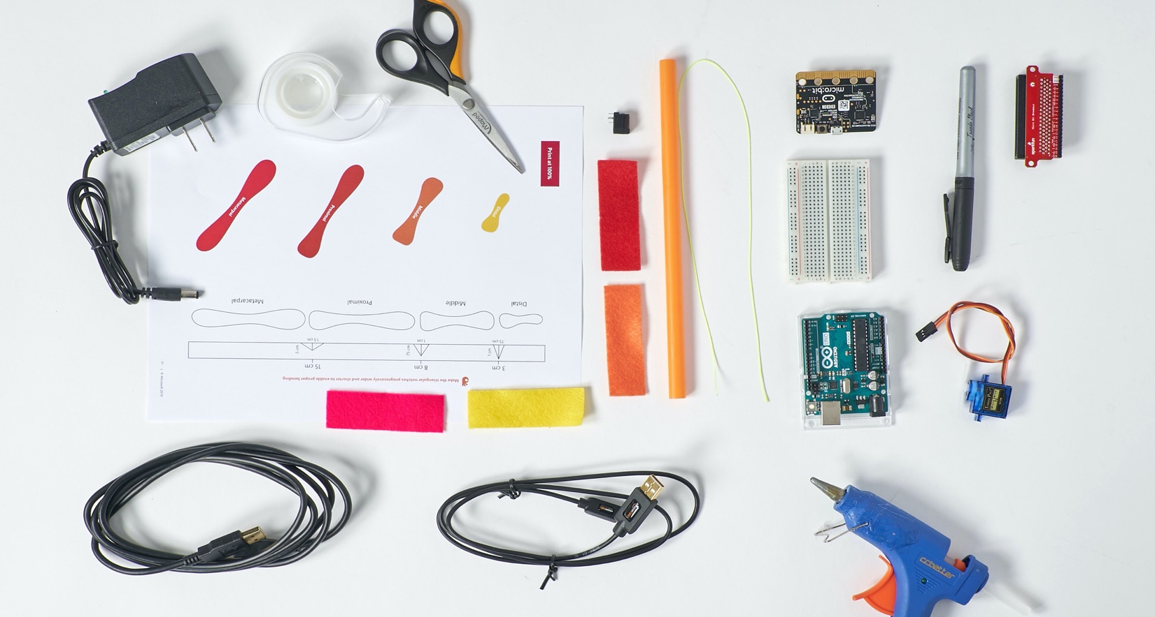

|  |
| --- |
| Things you’ll need to build one (1) finger |

**Materials: Articulated Finger**

1 milkshake or Boba straw

50 cm braided dacron kite thread, or fishing line

Felt (c)

1 straw and felt template (page 68)

Optional: 1 large rubber band

**Electronics**

1 5V power supply

1 barrel jack breadboard adapter

1 servo motors with arms

**Arduino Uno**

1 half-size breadboard

1 mini breadboard

1 Arduino Uno

1 USB cable A-to-B (for Arduino)

**OR**

**micro:bit**

*Note: use your* ***second*** *micro:bit for the articulated finger*

1 half-size breadboard

1 micro:bit

1 edge connector

1 microUSB cable

**Toolkit**

scissors

tape

hot melt tool

permanent marker

***Safety guidelines***

***Hot Melt Tool***

* *Place it on a level surface to avoid tipping over.*
* *Place the electrical cable out of the way to avoid a tripping hazard.*
* *Do not touch the tip of the tool or the hot glue coming out of it.*

***Eye Protection***

* *Please wear appropriate eye protection while doing any engineering design or field projects.*

***Cutting Tools***

* *Keep the sharp edge away from your body.*
* *Always cover the blade with a plastic cap when not in use.*
* *When cutting small pieces, do not place fingers very closed to the blades.*

***Wire Strippers***

* *Always keep your fingers and hands out of the cutting area.*

Construct your finger

|  |  |  |
| --- | --- | --- |
|  |  |  |
| **1** | Cut out your template and align straw. Use this template as a stencil for making each articulated finger. |  | **2** | Using your spacing guide, mark location of cuts on the straw. |
|  |  |  |
| ../../../../../Desktop/Picture1.png |  |  |
| **3** | Bend your straw at the marks and cut diagonally. |  | **4** | Grab your 50 cm thread and drop it through the straw, leaving about 7 cm hanging out of the top (the distal end). |
|  |  |  |
|  |  |  |

|  |  |  |
| --- | --- | --- |
| **5** | Wind your thread around the top section twice. |  | **6** | Tape your thread to the straw. |

|  |  |  |
| --- | --- | --- |
|  |  |  |
| **7 |** Check your finger functionality by pulling the thread. The digits should bend progressively and in order, from top to bottom.  ***Note****: Straw not bending as expected? Try different cutting techniques and shapes. Test and improve based on your observations.* |  | **8 |** Apply your bone labels. |
|  |  |  |
| **9 |** Cut out the finger bones from the felt, using the Articulated Finger template as a guide. |  | **10 |** Hot glue the felt bones to your articulated finger opposite your cut holes, except for the metacarpal, which will be applied a bit later when building the robotic finger. |
|  |  |  |
|  |  | Cropped%20Images/Step-11.png |
| **11 |** Optional: Cut the rubber band into small pieces and glue them opposite the bones, to act as finger pads and provide grip. |  | **12 |** Test your articulated finger by pulling the string.  **Congratulations! You’ve built an articulated finger!** |
|  |  |  |

Construct the fingers for the hand

If you are building the whole hand, follow the steps below otherwise skip this page.

|  |  |  |
| --- | --- | --- |
|  |  |  |
| **11 | Building the whole hand?** Repeat steps 1-10 to complete 3 more articulated fingers and a thumb. Otherwise skip to the next section.  ***Note****: If you are working in a group of five, four of your team members should build a finger and one should build a thumb (see next steps).* |  | **12 |** Make a thumb by cutting an articulated finger, then removing the bottom section which would act as the metacarpal on the finger. |
|  |  |  |
|  |  |  |
| **13 |** Attach finger bone labels as shown. |  | **14 |** Cut out felt bones and attach to the thumb. Follow the steps to complete the thumb with finger pads and the cardboard, as done in the finger instructions. |

Build the hand

|  |  |  |  |
| --- | --- | --- | --- |
|  |  |  |  |
| **1 |** Use the robotic hand template to cut out the **index finger** and base of the robotic hand. See page 74, 76 for templates. |  | **2 |** Grab your felt finger bones from the Articulated Finger section. Glue your metacarpal bone to the opposite side of the cutout on a cardboard finger piece. |  |
|  |  |  |  |
|  |  |  |  |
| **3 |** Flip over your cardboard piece and glue the articulated finger to the other side. |  | **4 |** The rectangular cutout at the bottom of the cardboard will house the servo. |  |
|  |  |  |  |
|  |  |  |  |
| **5 |** Insert your servo motor into the articulated finger as shown, with the bulk of the motor sitting on the side where the felt bones are attached. |  | **6 |** Secure your servo to the cardboard with hot glue. |  |

|  |  |  |
| --- | --- | --- |
|  |  |  |
| **7 |** Attach your servo arm to the motor and rotate it to the right as far as it will go. Then, remove the servo arm and reattach it so that it is vertical with the longer arm is pointing directly towards the straw. |  | **8 |** Thread your string through the top hole of the servo. |
|  |  |  |
|  |  |  |
| **9 |** Pull your string tight so that the distal bone is slightly flexed. |  | **10 |** Using a “figure 8” motion, wrap your string around the cross bar several times to keep the string tight. Tape or glue the string to secure it to the servo arm and trim it as needed. Set aside. |

|  |  |  |
| --- | --- | --- |
|  |  |  |
| **11 |** Gather your remaining cardboard pieces. |  | **12 |** Take the smallest of your 3 pieces, and glue it upright to the center of the base with the middle slit facing up. |
|  |  |  |
|  |  |  |
| **13 |** Locate the slit in your cardboard palm piece and slide that piece over the base support. |  | **14 |** Attach your robotic index finger to the palm piece by fitting the servos into the punch out. |
|  |  |  |
|  |  |  |
| **15 |** Secure your robotic finger with glue. |  | Congratulations! You are now ready to wire your articulated finger. |

Connect an external power supply

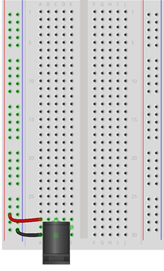

|  |  |  |
| --- | --- | --- |
|  |  |  |
| **1 |** Grab your barrel jack connector. This connector has three pins: the **back pin is the positive connector** and the **bottom pin is the negative, or ground, connector.** For our purposes, ignore the side, middle pin. |  | **2 |** Insert your barrel jack connector into three unused rows at the bottom of the half-size breadboard so that the input hole faces away from the breadboard.  ***Note****: This is the input for the external power supply that will power the servo motors.* |
| **3 |** Connect your next jumper wire between the negative barrel jack pin and the negative breadboard power rail.  ***Note****: This connects the power supply and Arduino ground references together so that the signals are consistent.* |  | **4 |** Connect one of your jumper wires between the positive barrel jack pin and the positive breadboard power rail. |
|  |  |  |
|  |  |  |

Circuit images made with Fritzing and are licensed for use under CC by SA 3.0. See <http://creativecommons.org/licenses/by-sa/3.0/> for the full description.

Connect articulated finger to Arduino Uno

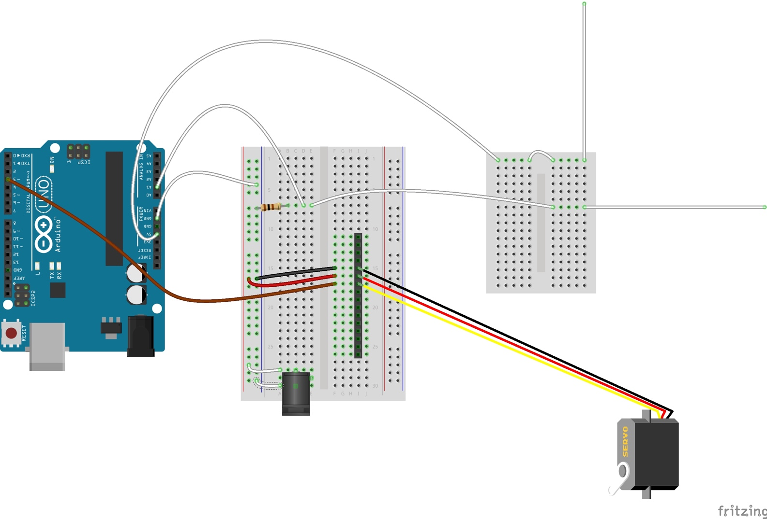

|  |  |  |
| --- | --- | --- |
| **1 |** Insert your 15-pin header into the half-size breadboard so that each pin is in an unused row, as shown in the diagram. |  | **2 |** Plug your 3-pin servo cable into the pin header as shown in the diagram. |
| **3 *|*** Connect your first jumper wire from the servo signal wire (yellow or orange wire) to Arduino Digital Pin **3**. |  | **4 |** Connect your next jumper wire from the servo power wire (red wire) to the half-size breadboard positive power rail. |
| **5 |** Connect your next jumper wire from the servo ground wire (black or brown wire) to the negative breadboard power rail. |  |  |

Circuit images made with Fritzing and are licensed for use under CC by SA 3.0. See <http://creativecommons.org/licenses/by-sa/3.0/> for the full description.

Connect articulated finger to micro:bit

|  |  |  |
| --- | --- | --- |
|  |  |  |
| **1 |** Grab your **second** set of micro:bit materials: micro:bit, edge connector, half-size breadboard, microUSB Cable. Label this micro:bit “Articulated Finger.” |  | **2 |** Connect your micro:bit into the computer with the microUSB cable and load the Articulated Finger code onto the micro:bit as shown in Appendix I: Software. |
| Machine generated alternative text: |  |  |
| **3 |** Insert the micro:bit edge connector into the breadboard. |  | **4 |** Plug the micro:bit into the edge connector. |

Connect articulated finger to micro:bit

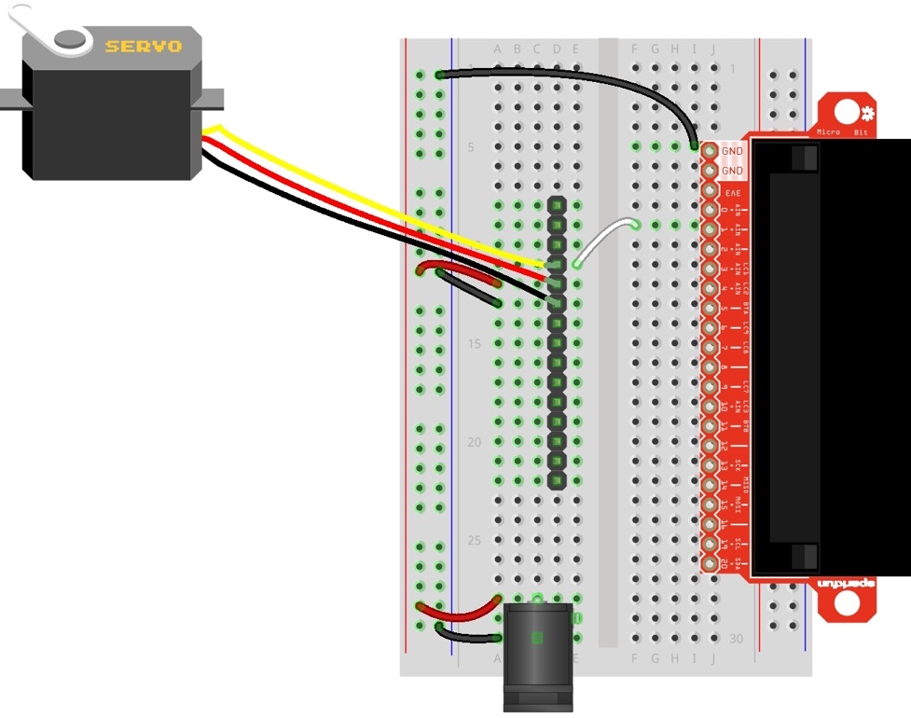

|  |  |  |
| --- | --- | --- |
| **1 |** Connect your first jumper wire between a micro:bit GND pin and the negative power rail on the breadboard.  *Note: This connects the power supply and micro:bit ground references together so that the signals are consistent.* |  | **2 |** Insert the 15-pin header pins into the breadboard so that each pin is in an unused row. |
| **3 |** Plug your 3-pin servo cable into the pin header, as shown in the diagram. |  | **4 |** With your first jumper wire, connect the servo signal wire (yellow or orange wire) to micro:bit pin **1** as shown in the diagram. |
| **5 |** Connect the servo power wire (red wire) to the breadboard positive power rail. |  | **6 |** Connect the power ground wire (black or brown wire) to the breadboard negative power rail. |

Circuit images made with Fritzing and are licensed for use under CC by SA 3.0. See <http://creativecommons.org/licenses/by-sa/3.0/> for the full description.

Test the Articulated Robotic Finger

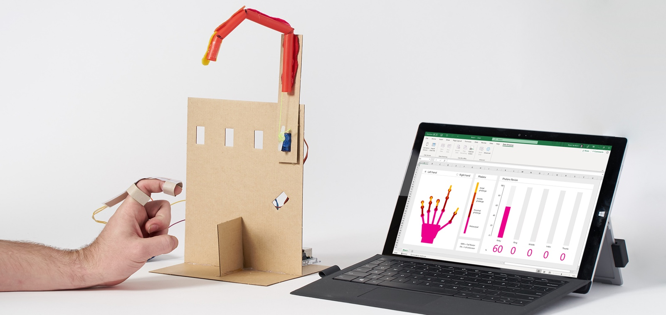

|  |  |  |
| --- | --- | --- |
| **1 |** Plug your external 5V power supply into the breadboard barrel jack and connect it to an electrical outlet. |  | **2 |** Connect your microcontroller with a USB cable to the computer and open the Excel workbook. Navigate to the Data Streamer tab. |
| **3 |** Start data collection in data streamer. Move the finger sensor(s) and check that it moves the articulated robotic finger. |  |  |

**TROUBLESHOOTING**

If your servo motor doesn’t work, follow this troubleshooting process.

**Problem:** All flex sensors show -1 on Data In workbook tab.

**Solution:** Flex sensor and servo motor connectors are reversed on the microcontroller. Check the microcontroller pin connections one by one.

**Problem:** My sensorized finger doesn’t move the robotic finger.

**Solutions:**

* Power is not reaching the servo motor. Double check that you have the external power supply plugged in and that the wires are connected correctly as shown in the wiring diagrams.
* The sensor could be faulty in the glove. If so, remove and replace or acquire one that's working to check that the leads are working.
* The servo motor is fried. Double check that your power supply is 5V and then replace the servo.
* The servo connector is backwards—re-orient the plug connector into the header pins on your breadboard.
* Clear plastic servo arm holding the thread may have fallen off or is loose.
* Make sure that your microcontroller is flashed using the correct code.
* Make sure that you're using the correct Excel Workbook—each Hacking STEM project comes with its own customized workbook.

**Problem -** Excel Round 4 and 5 icons don’t change.

**Solution -** Set Data channels to 22 or higher in the Workbook Settings tab.



**ROBOTIC HAND**

Glove controller

Lesson plan and more resources are available at: <https://aka.ms/robotic-hand>

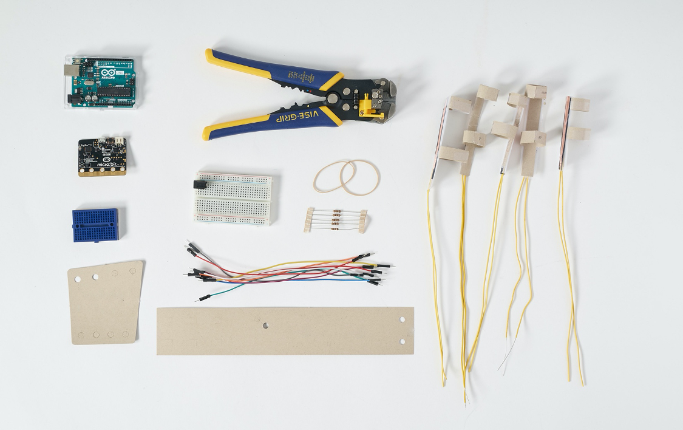

|  |
| --- |
|  |
| Things you’ll need to build a Sensor Glove   |  |  | | --- | --- | | **Materials**  5 completed flex sensors  1 cardstock palm plate and wrist cuff glove controller cutouts (page 70, 72)  2 rubber bands  13 male-to-male jumper wires  5 100 Ohm Resistors  1 breadboard    **Arduino Uno**  Note: Use the same Arduino board for all sections  **OR**  **micro:bit**  Note: Use the **flex sensor** micro:bit | **Toolkit**  hot melt tool  wire strippers  ***Safety guidelines***  ***Wire Strippers***   * *Always keep your fingers and hands out of the cutting area.* | |

**Making for a group or need help finding materials?**

View the shopping list to calculate quantities and links to materials at: aka.ms/robotichandshoppinglist.

Make the Glove Controller

|  |  |  |
| --- | --- | --- |
|  |  | Machine generated alternative text: |
| **1 |** Grab your cardstock wristband and palm plate cutouts from the Flex Sensor section. |  | **2 |** Thread your finger sensors through the holes in of the metacarpal (palm) plate. |
|  |  |  |
|  |  |  |
| **3 |** Tie rubber bands through the bottom left and right holes of the plate. |  | **4 |** Using your hot glue gun, attach the mini breadboard to the wristband cardboard. Be mindful of left hand versus right hand.  ***Note****: If using the micro:bit, glue the* ***finger******sensor*** *breadboard.* |
|  |  |  |
|  |  |  |
| **5 |** Push your rubber bands through the bottom loops of the wristband cuff. |  | **6 |** Try on the glove controller to check that it fits and that the wire connections are secure. You have completed your glove controller and are now ready to connect the flex sensors to your microcontroller! |
|  |  |  |

Connect sensors to Arduino Uno

**Index finger**

**Index 1**

**Index 2**

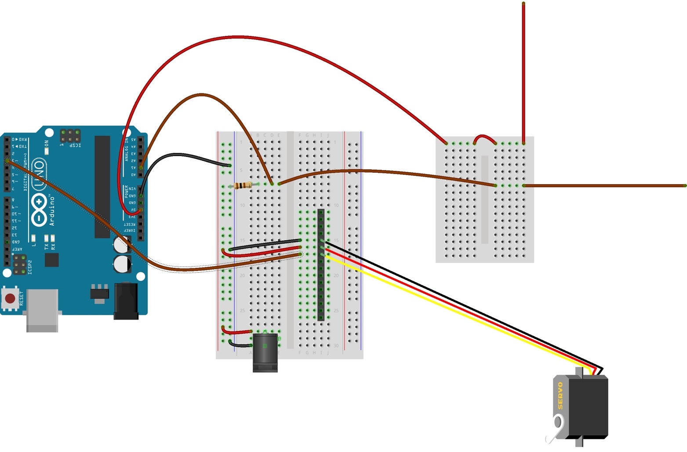

|  |
| --- |
| In the previous section “Build a flex sensor,” you should have already built the index finger. Your breadboard should look as it does above.  If not, no worries, return to the previous section and return here to build the rest of the hand. |
|  |
|  |
|  |

 Circuit images made with Fritzing and are licensed for use under CC by SA 3.0. See <http://creativecommons.org/licenses/by-sa/3.0/> for the full description.

Connect sensors to Arduino Uno (cont.)

**Thumb**

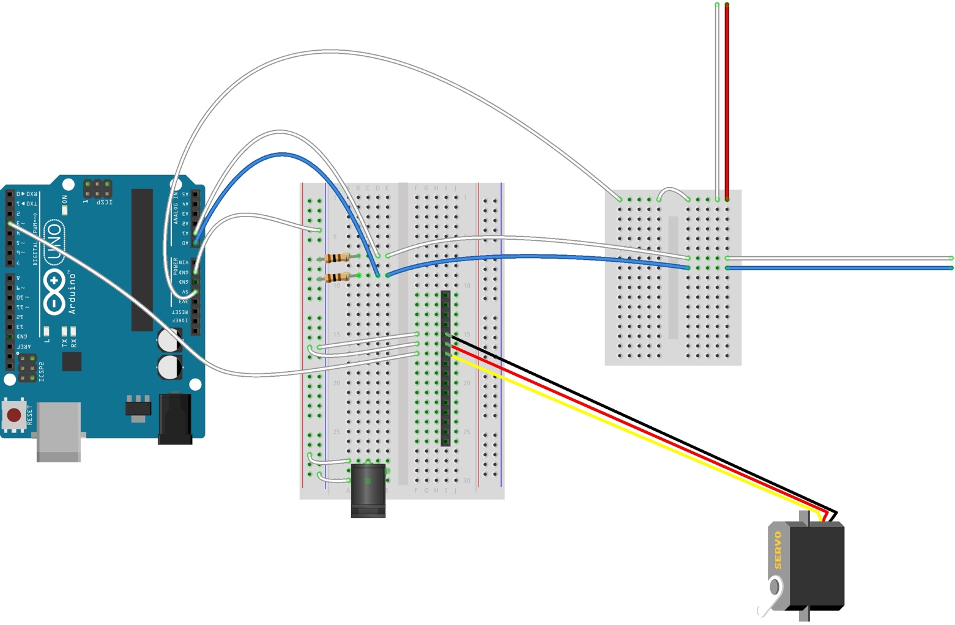

**Thumb 2**

**Thumb 1**

|  |  |  |
| --- | --- | --- |
| **1 |** Grab your thumb flex sensor. Connect the one of the flex sensor wires into the top row of the mini breadboard as shown in the diagram. |  | **2 |** Connect the second thumb flex sensor wire into an open row on the mini breadboard. |
| **3 |** Connect a jumper wire between the second thumb flex sensor wire and an open row on the half-size breadboard, as shown on the diagram. |  | **4 |** On the half-size breadboard, connect your second 100-ohm resistor between the second flex sensor wire and the negative power rail. |
| **5 |** Connect your next jumper cable from the Arduino analog pin **A0** and the second flex sensor wire, as shown on the diagram. |  | **6 |** Check that your sensor works as expected by repeating the testing procedure outlined in "Test the Sensor." |

  Circuit images made with Fritzing and are licensed for use under CC by SA 3.0. See <http://creativecommons.org/licenses/by-sa/3.0/> for the full description.

Connect sensors to Arduino Uno (cont.)

**Middle Finger**

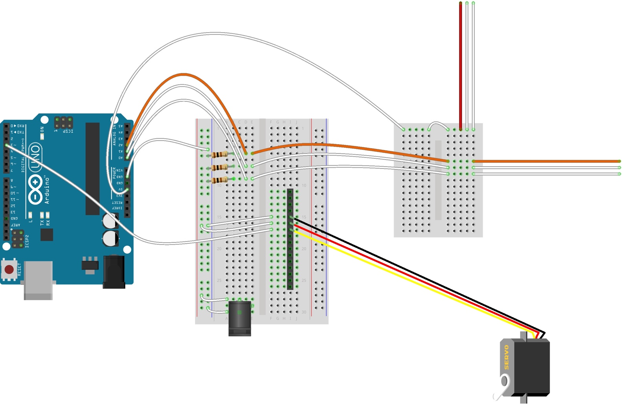

**Middle 1**

**Middle 2**

|  |  |  |
| --- | --- | --- |
| **1 |** Grab your middle finger flex sensor. Connect one of the sensor wires into the top row of the mini breadboard as shown in the diagram. |  | **2 |** Connect the second middle finger flex sensor wire into an open row on the mini breadboard. |
| **3 |** Connect a jumper wire between the second middle finger flex sensor wire and an open row on the half-size breadboard, as shown on the diagram. |  | **4 |** On the half-size breadboard, connect your third 100-ohm resistor between the second flex sensor wire and the negative power rail. |
| **5 |** Connect your next jumper cable from the Arduino analog pin **A2** and the second flex sensor wire, as shown on the diagram. |  | **6 |** Check that your sensor works as expected by repeating the testing procedure outlined in "Test the Sensor." |

 Circuit images made with Fritzing and are licensed for use under CC by SA 3.0. See <http://creativecommons.org/licenses/by-sa/3.0/> for the full description.

Connect sensors to Arduino Uno (cont.)

**Ring finger**

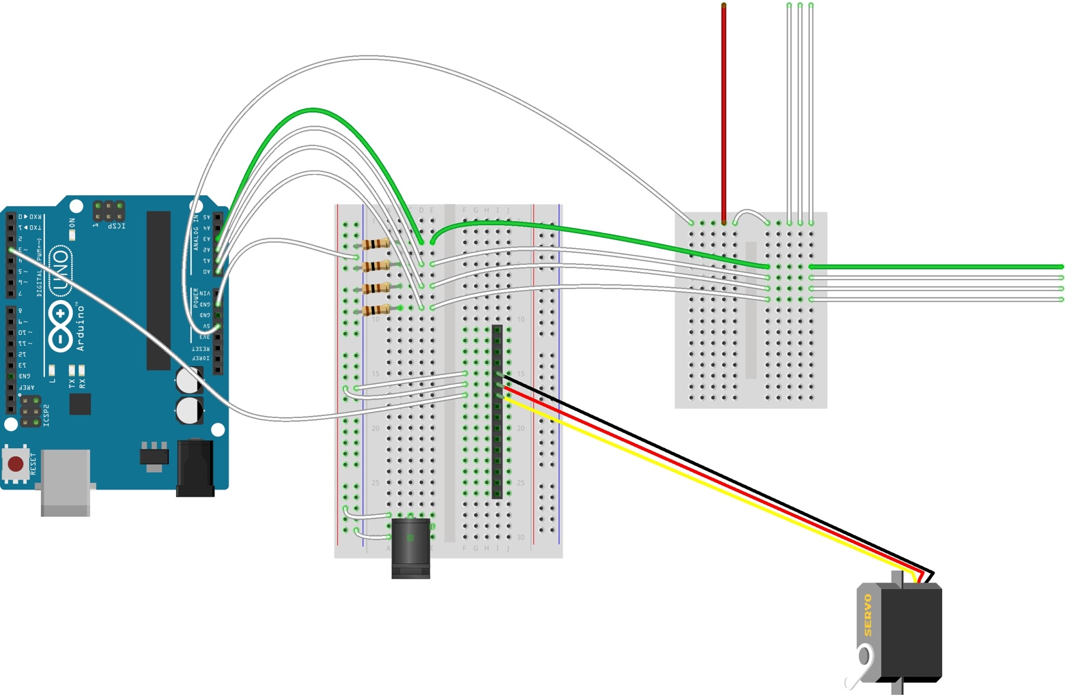

**Ring 1**

**Ring 2**

|  |  |  |
| --- | --- | --- |
| **1 |** Grab your ring finger flex sensor. Connect one of the sensor wires into the top row of the mini breadboard as shown in the diagram. |  | **2 |** Connect the second ring finger flex sensor wire into an open row on the mini breadboard. |
| **3 |** Connect a jumper wire between the second ring finger flex sensor wire and an open row on the half-size breadboard, as shown on the diagram. |  | **4 |** On the half-size breadboard, connect your fourth 100-ohm resistor between the flex sensor wire and the negative power rail. |
| **5 |** Connect your next jumper cable from the Arduino analog pin **A3** and the second flex sensor wire, as shown on the diagram. |  | **6 |** Check that your sensor works as expected by repeating the testing procedure outlined in "Test the Sensor." |

 Circuit images made with Fritzing and are licensed for use under CC by SA 3.0. See <http://creativecommons.org/licenses/by-sa/3.0/> for the full description.

Connect sensors to Arduino Uno (cont.)

**Pinky finger**

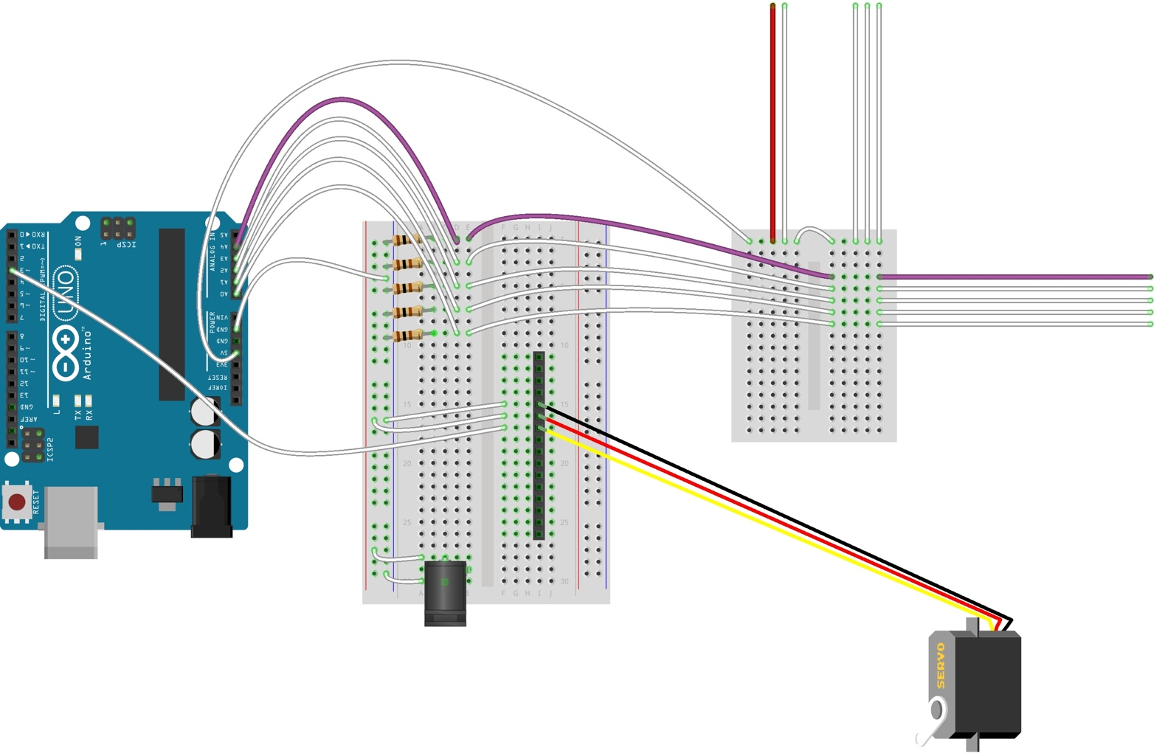

**Pinky 1**

**Pinky 2**

|  |  |  |
| --- | --- | --- |
| **1 |** Grab your pinky finger flex sensor. Connect one of the sensor wires into the top row of the mini breadboard as shown in the diagram. |  | **2 |** Connect the second pinky finger flex sensor wire into an open row on the mini breadboard. |
| **3 |** Connect a jumper wire between the second pinky finger flex sensor wire and an open row on the half-size breadboard, as shown on the diagram. |  | **4 |** On the half-size breadboard, connect your fifth 100-ohm resistor between the second flex sensor wire and the negative power rail. |
| **5 |** Connect your next jumper cable from the Arduino analog pin **A4** and the second flex sensor wire, as shown on the diagram. |  | **6 |** Check that your sensor works as expected by repeating the testing procedure outlined in "Test the Flex Sensors." |

Circuit images made with Fritzing and are licensed for use under CC by SA 3.0. See <http://creativecommons.org/licenses/by-sa/3.0/> for the full description.

Connect sensors to micro:bit

**Index finger**

|  |
| --- |
| **Index 1**  **Index 2** |
| |  | | --- | | In the previous section “Build a flex sensor,” you should have already built the index finger. Your breadboard should look as it does above.  If not, no worries, return to the previous section and return here to build the rest of the hand. |   Circuit images made with Fritzing and are licensed for use under CC by SA 3.0. See <http://creativecommons.org/licenses/by-sa/3.0/> for the full description. |

Connect sensors to micro:bit (cont.)

**Thumb**

|  |
| --- |
| **Thumb 2**  **Thumb 1** |
| |  |  |  | | --- | --- | --- | | **1 |** Grab your thumb flex sensor. Connect one of the thumb flex sensor wires to the breadboard positive power rail. |  | **2 |** Connect the second thumb flex sensor wire to the micro:bit input **pin 0**. | | **3 |** Connect your next 100-Ohm resistor between the second thumb flex sensor wire and the breadboard negative power rail, as shown in the diagram above.  ***Note****: Orientation of the resistor does not matter.* |  |  |     Circuit images made with Fritzing and are licensed for use under CC by SA 3.0. See <http://creativecommons.org/licenses/by-sa/3.0/> for the full description. |

Connect sensors to micro:bit (cont.)

**Middle finger**

|  |
| --- |
| **Middle 2**  **Middle 1** |
| |  |  |  | | --- | --- | --- | | **1 |** Grab your middle finger flex sensor. Connect one of the sensor wires to the breadboard positive power rail. |  | **2 |** Connect the second middle finger flex sensor wire to the micro:bit input **pin 2**. | | **3 |** Connect your next 100-Ohm resistor between the second middle finger flex sensor wire and the breadboard negative power rail, as shown in the diagram above.  ***Note****: Orientation of the resistor does not matter.* |  |  |     Circuit images made with Fritzing and are licensed for use under CC by SA 3.0. See <http://creativecommons.org/licenses/by-sa/3.0/> for the full description. |

Connect sensors to micro:bit (cont.)

**Ring finger**

|  |
| --- |
| **Ring 1**  **Ring 2** |
| |  |  |  | | --- | --- | --- | | **1 |** Grab your ring finger flex sensor. Connect one of the sensor wires to the breadboard positive power rail. |  | **2 |** Connect the second ring finger flex sensor wire to the micro:bit input **pin 3**. | | **3 |** Connect your next 100-Ohm resistor between the second ring finger flex sensor wire and the breadboard negative power rail, as shown in the diagram above.  ***Note****: Orientation of the resistor does not matter.* |  |  |     Circuit images made with Fritzing and are licensed for use under CC by SA 3.0. See <http://creativecommons.org/licenses/by-sa/3.0/> for the full description. |

Connect sensors to micro:bit (cont.)

**Pinky finger**

|  |
| --- |
| **Pinky 2**  **Pinky 1** |
| |  |  |  | | --- | --- | --- | | **1 |** Grab your pinky finger flex sensor. Connect one of the sensor wires to the breadboard positive power rail. |  | **2 |** Connect the second pinky finger flex sensor wire to the micro:bit input **pin 4**. | | **3 |** Connect your last 100-Ohm resistor between the second pinky finger flex sensor wire and the breadboard negative power rail, as shown in the diagram above.  ***Note****: Orientation of the resistor does not matter.* |  |  |     Circuit images made with Fritzing and are licensed for use under CC by SA 3.0. See <http://creativecommons.org/licenses/by-sa/3.0/> for the full description. |

Test the flex sensors



|  |  |  |
| --- | --- | --- |
| **1 |** Test that the flex sensor functions correctly by connecting your microcontroller to your computer via USB and opening the Excel workbook. |  | **2 |** Start data collection and then move the flex sensor. If everything is working properly, you will see the corresponding finger in the workbook move as you move the flex sensor.  ***Note:*** *unconnected fingers may appear to be moving due to random signals from the microcontroller– neglect this until all sensors are connected.* |

**TROUBLESHOOTING**

If your finger flex sensor doesn’t work, follow this troubleshooting process.

**Problem:** The corresponding finger in the Excel simulation does not move or moves randomly.

**Possible Solutions**:

* The sensor readings take some time to settle. Wait for a few seconds and then retry.
* Double check the finger sensor connections to your microcontroller.
* Arduino connections: The index finger connects to analog pin A1, the thumb to A0, middle finger to A2, ring finger to A3, and pinky finger to A4.
* micro:bit connections: The index finger connects to pin 1, the thumb to 0, middle finger to 2, ring finger to 3, and pinky finger to 4.
* Check that the microcontroller is plugged in and the appropriate code successfully uploaded to the board.
* The sensor could be faulty in the glove. If so, remove and replace or acquire one that's working to check that the leads are properly connected.
* Make sure that you're using the correct Excel Workbook—each Hacking STEM project comes with its own customized workbook.

*Still not working? Ask a classmate, your teacher, or reach out to us at: aka.ms/hackingSTEM*

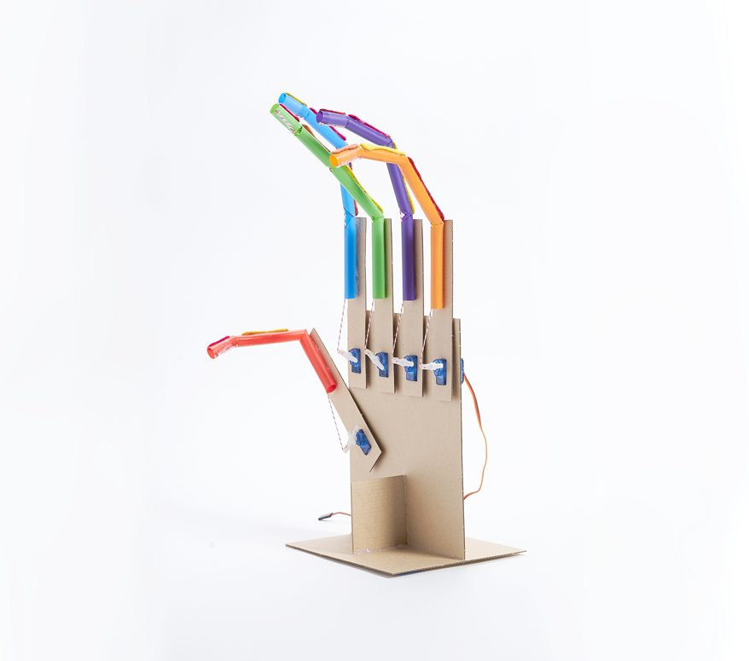

**ROBOTIC HAND**

Robotic hand

Lesson plan and more resources are available at: <https://aka.ms/robotic-hand>

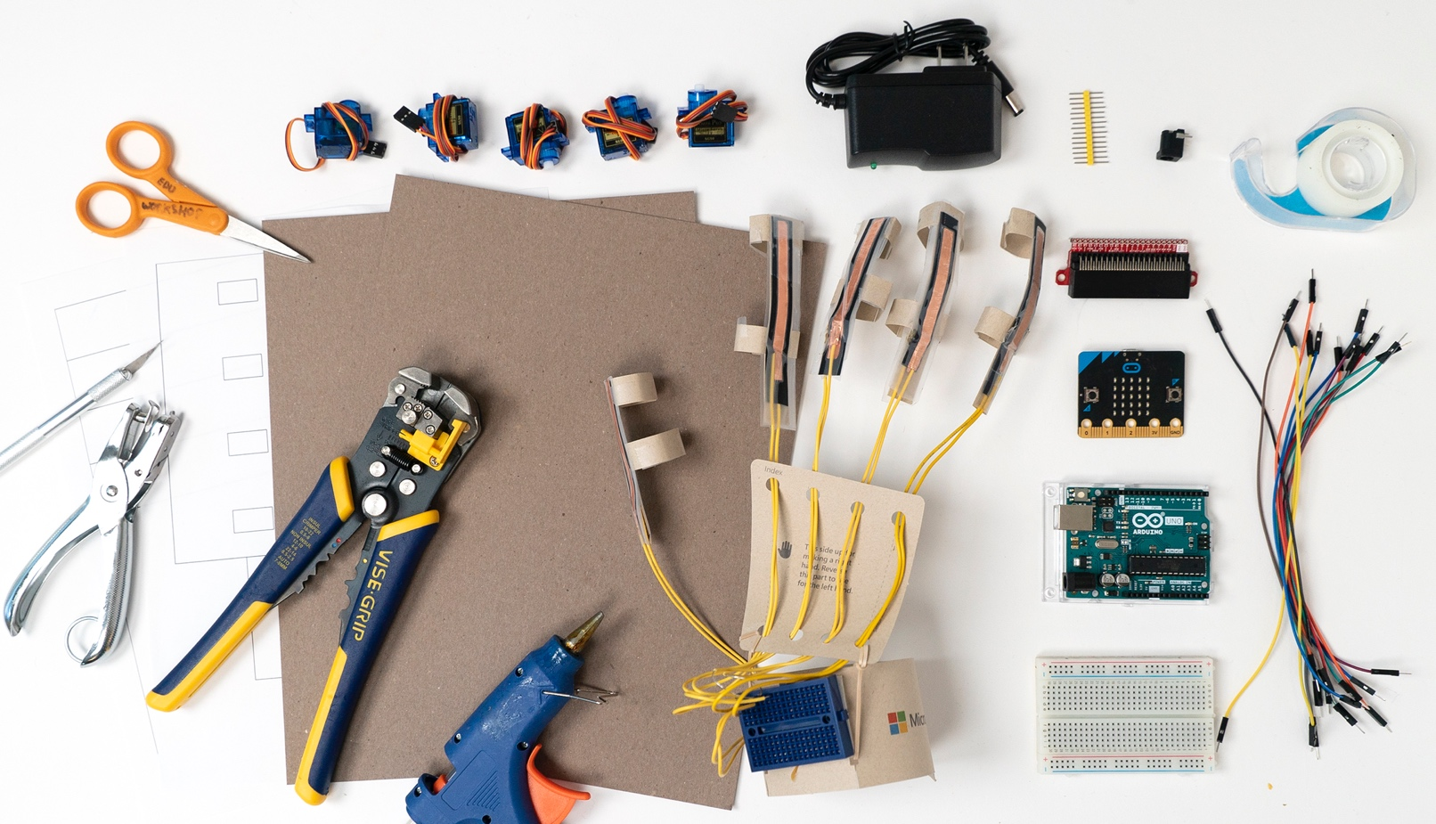

|  |
| --- |
|  |
| Things you’ll need for the robotic hand   |  |  | | --- | --- | | **Materials**  1 completed glove controller  5 completed articulated fingers  5 servo motors with arms  17 solderless breadboard jumper wires  1 5V power supply  1 barrel jack breadboard adapter  2 pieces of lightweight chipboard or heavyweight  cardstock (22 cm x 28 cm)  1 robotic hand template (pg. 74, 76)    **Arduino Uno**  Note: Use the same Arduino board for all sections  **OR**  **micro:bit**  Note: Use the **Articulated Finger** micro:bit | **Toolkit**  scissors  clear tape  wire strippers  single hole punch  utility knife  duct tape  hot melt tool  ***Safety guidelines***  ***Wire Strippers***   * *Always keep your fingers and hands out of the cutting area.* | |

**Making for a group or need help finding materials?**

View the shopping list to calculate quantities and links to materials at: aka.ms/robotichandshoppinglist.

Build the hand

|  |  |  |  |
| --- | --- | --- | --- |
|  |  |  |  |
| **1 |** Use the template to cut out the rest of the fingers for the robotic hand. See Appendix IV for templates. |  | **2 |** Grab your felt finger bones from the Articulated Finger section. Glue your metacarpal bone to the opposite side of the cutout on a cardboard finger piece. |  |
|  |  |  |  |
|  |  |  |  |
| **3 |** Flip over your cardboard piece and glue the articulated finger to the other side. |  | **4 |** The rectangular cutout at the bottom of the cardboard will house the servo. |  |
|  |  |  |  |

|  |  |  |
| --- | --- | --- |
|  |  |  |
| **5 |** Insert your servo motor into the articulated finger as shown, with the bulk of the motor sitting on the side where the felt bones are attached. |  | **6 |** Secure your servo to the cardboard with hot glue. |
|  |  |  |
|  |  |  |
| **7 |** Attach your servo arm to the motor and rotate it to the right as far as it will go. Then, remove the servo arm and reattach it so that it is vertical with the longer arm is pointing directly towards the straw. |  | **8 |** Thread your string through the top hole of the servo. |
|  |  |  |
|  |  |  |
| **9 |** Pull your string tight so that the distal bone is slightly flexed. |  | **10 |** Using a “figure 8” motion, wrap your string around the cross bar several times to keep the string tight. Tape or glue the string to secure it to the servo arm and trim it as needed. Set aside. |

|  |  |  |
| --- | --- | --- |
|  |  |  |
| **13 |** Secure your robotic fingers with glue. |  | **14 |** Repeat steps 1 – 15 for all remaining fingers and thumb. **Nice work!** Your robotic hand is now ready to be connected to the microcontroller. |
|  |  |  |
|  |  |  |
|  |  |  |
|  |  |  |

Connect articulated fingers to Arduino Uno

**Index finger**

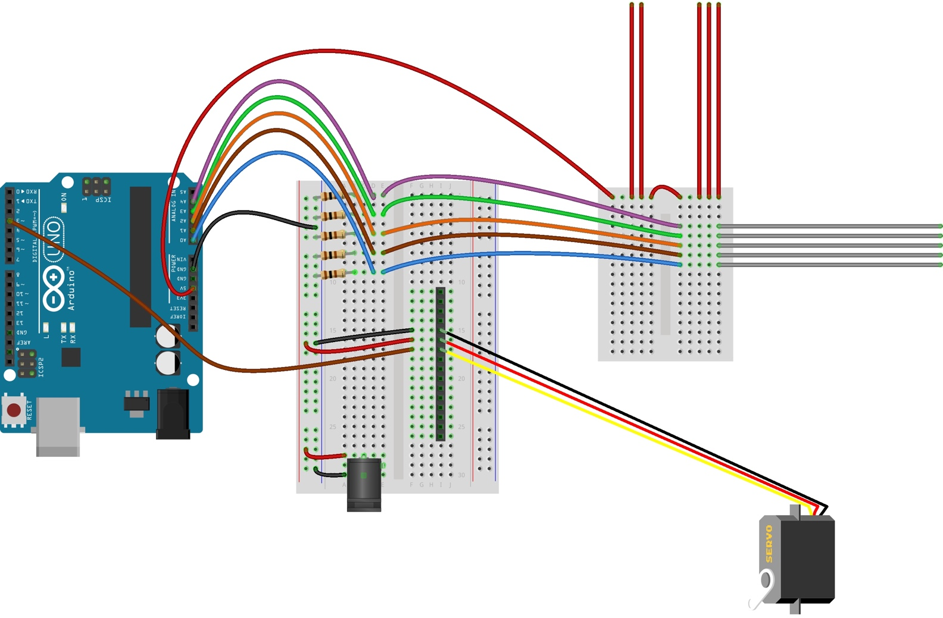

|  |
| --- |
| If you have completed the Flex Sensor, Articulated Finger, and Glove Controller sections your breadboard should look like the above diagram. |
|  |
|  |

Circuit images made with Fritzing and are licensed for use under CC by SA 3.0. See <http://creativecommons.org/licenses/by-sa/3.0/> for the full description.

Connect articulated fingers to Arduino Uno

**Thumb**

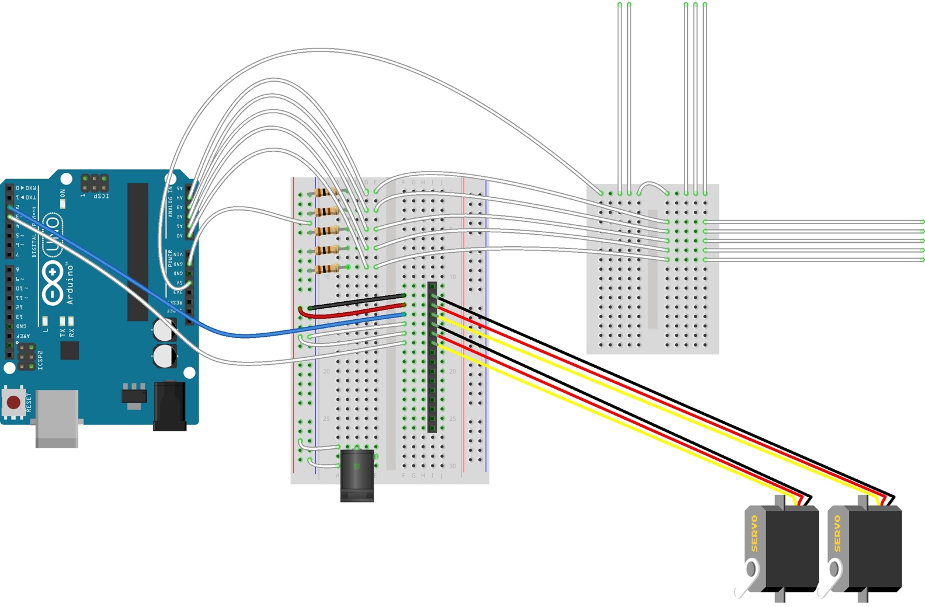

|  |  |  |
| --- | --- | --- |
| **1 |** Grab your next servo and plug the 3-pin servo cable into the pin header as shown in the diagram. |  | **2 |** Connect your first jumper wire from the servo signal wire (yellow or orange) to the Arduino Digitalpin **2**. |
| **3 |** Connect your next jumper wire from the servo power wire (red wire) to the half-size breadboard positive power rail. |  | **4 |** Connect your next jumper wire from the servo ground wire (black wire) to the negative power rail. |

 Circuit images made with Fritzing and are licensed for use under CC by SA 3.0. See <http://creativecommons.org/licenses/by-sa/3.0/> for the full description.

Connect articulated fingers to Arduino Uno

**Middle finger**

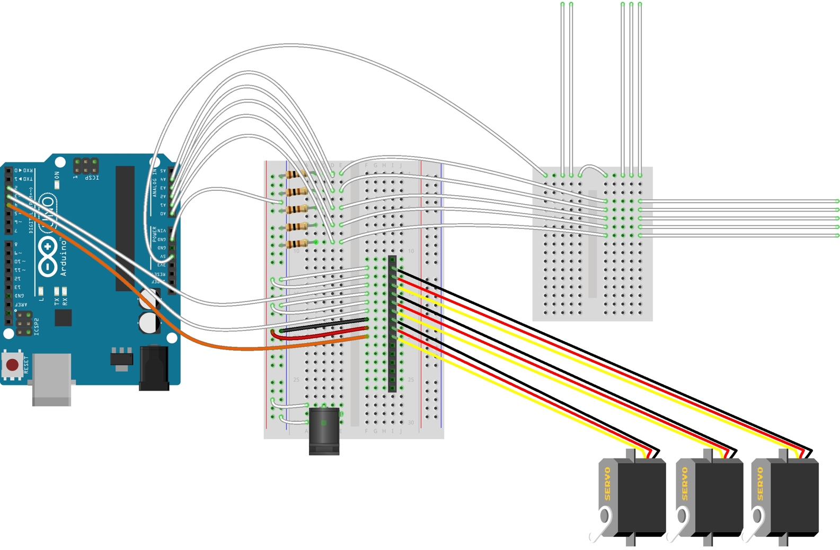

|  |  |  |
| --- | --- | --- |
| **1 |** Grab your third servo and plug the 3-pin servo cable into the pin header as shown in the diagram. |  | **2 |** Connect your first jumper wire from the servo signal wire (yellow or orange) to the Arduino Digitalpin **4**. |
| **3 |** Connect your next jumper wire from the servo power wire (red wire) to the half-size breadboard positive power rail. |  | **4 |** Connect your next jumper wire from the servo ground wire (black wire) to the negative power rail. |

 Circuit images made with Fritzing and are licensed for use under CC by SA 3.0. See <http://creativecommons.org/licenses/by-sa/3.0/> for the full description.

Connect articulated fingers to Arduino Uno

**Ring finger**

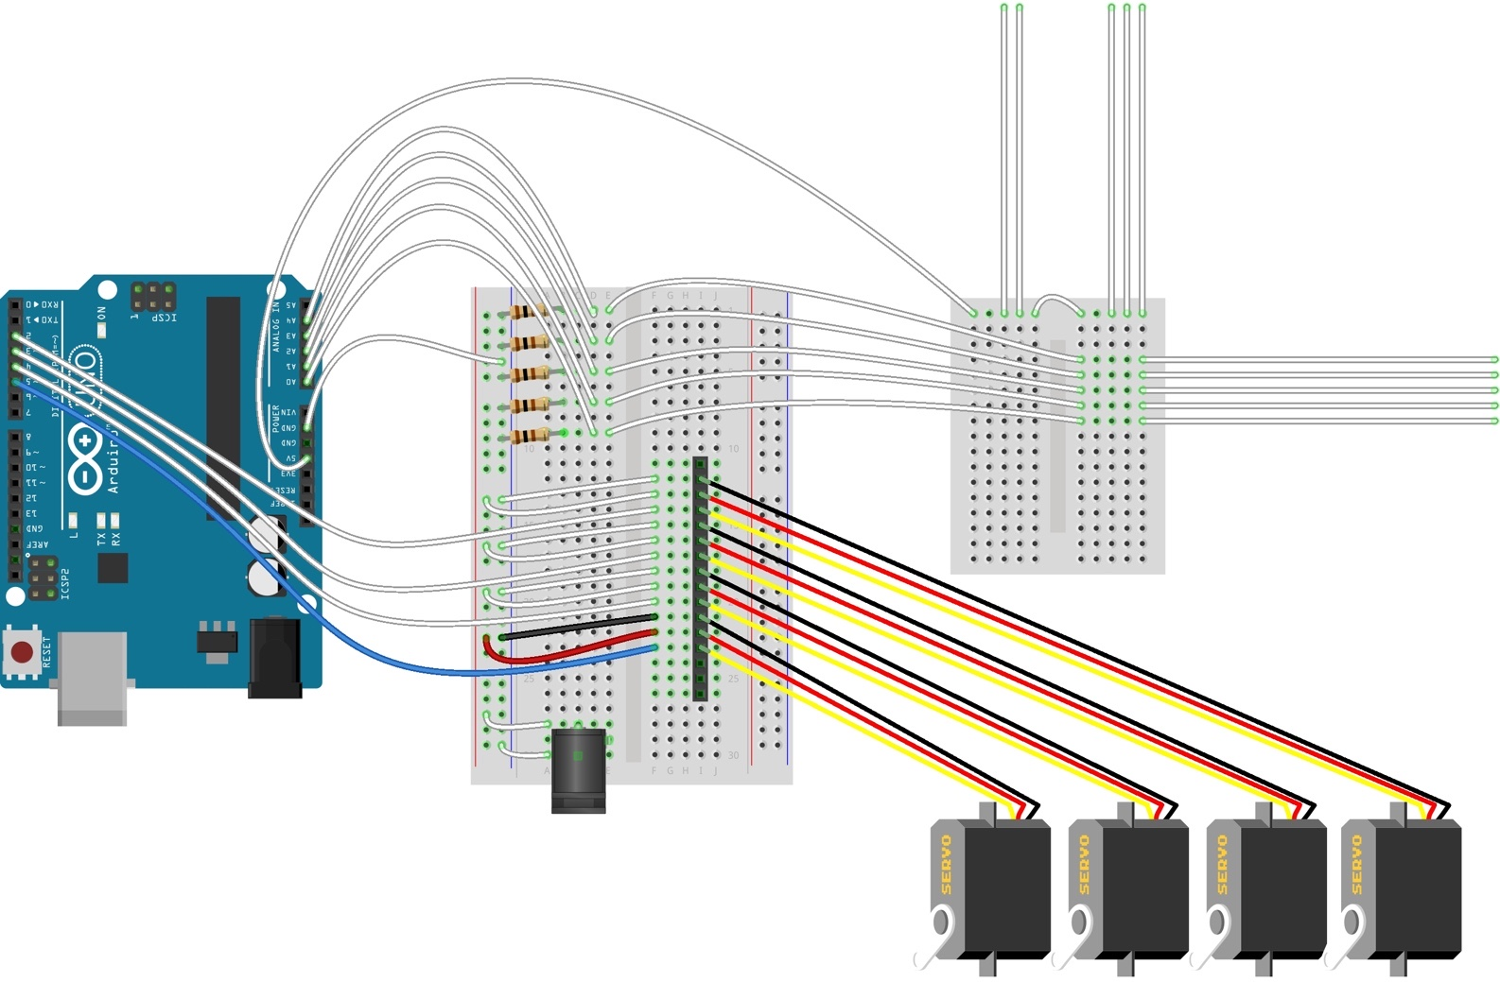

|  |  |  |
| --- | --- | --- |
| **1 |** Grab your fourth servo and plug the 3-pin servo cable into the pin header as shown in the diagram. |  | **2 |** Connect your first jumper wire from the servo signal wire (yellow or orange) to the Arduino Digitalpin **5**. |
| **3 |** Connect your next jumper wire from the servo power wire (red wire) to the half-size breadboard positive power rail. |  | **4 |** Connect your next jumper wire from the servo ground wire (black wire) to the negative power rail. |

 Circuit images made with Fritzing and are licensed for use under CC by SA 3.0. See <http://creativecommons.org/licenses/by-sa/3.0/> for the full description.

Connect articulated fingers to Arduino Uno

**Pinky finger**

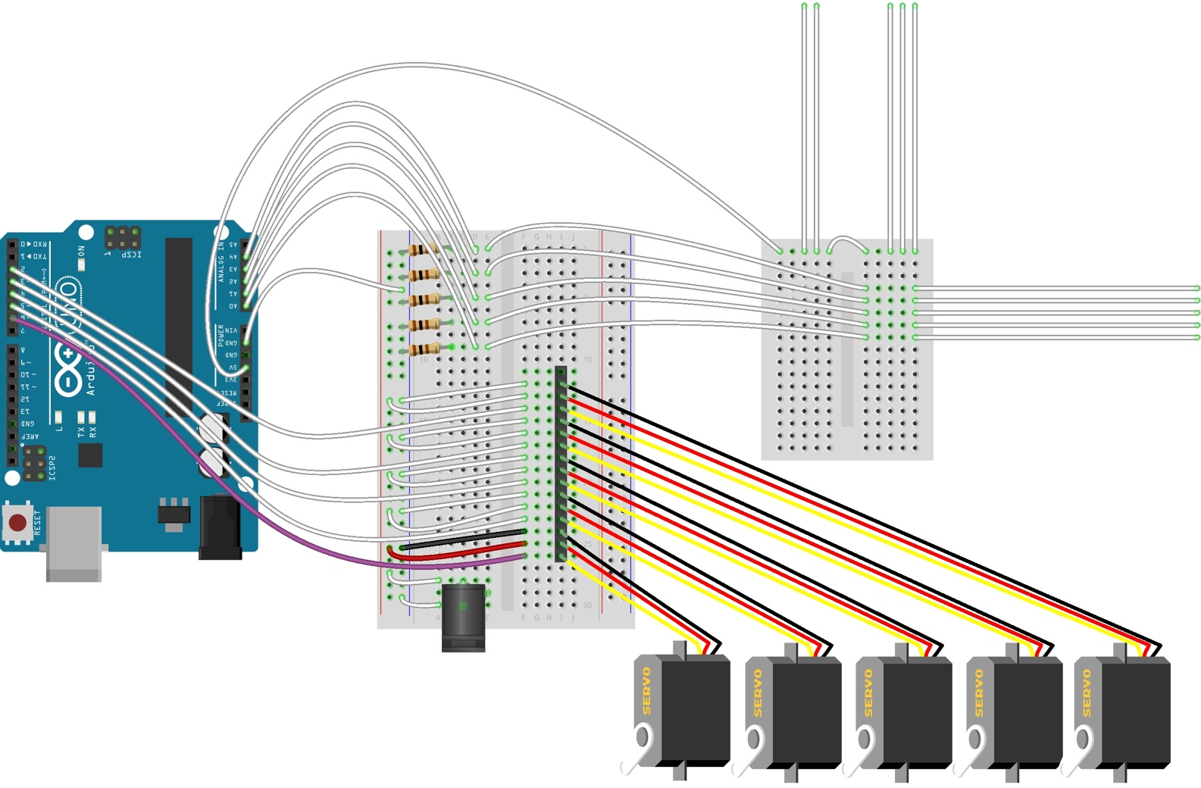

|  |  |  |
| --- | --- | --- |
| **1 |** Grab your fifth servo and plug the 3-pin servo cable into the pin header as shown in the diagram. |  | **2 |** Connect your first jumper wire from the servo signal wire (yellow or orange) to the Arduino Digitalpin **6**. |
| **3 |** Connect your next jumper wire from the servo power wire (red wire) to the half-size breadboard positive power rail. |  | **4 |** Connect your next jumper wire from the servo ground wire (black wire) to the negative power rail. |

Circuit images made with Fritzing and are licensed for use under CC by SA 3.0. See <http://creativecommons.org/licenses/by-sa/3.0/> for the full description.

Connect articulated fingers to micro:Bit

**Index finger**

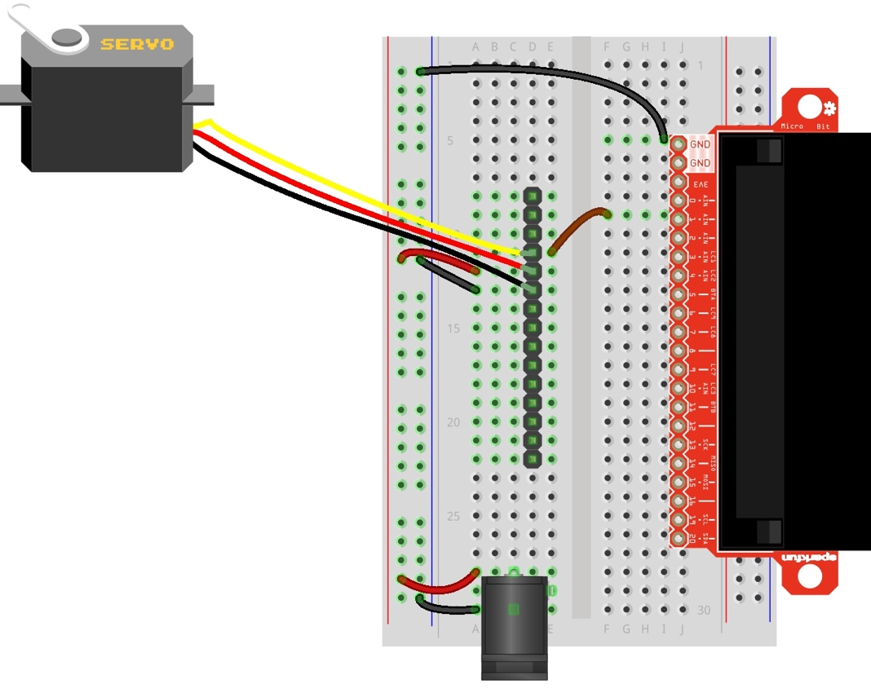

|  |
| --- |
| Grab your **articulated finger micro:bit,** your breadboard should look like the above diagram. |
|  |
|  |

Circuit images made with Fritzing and are licensed for use under CC by SA 3.0. See <http://creativecommons.org/licenses/by-sa/3.0/> for the full description.

Connect articulated fingers to micro:Bit

**Thumb**

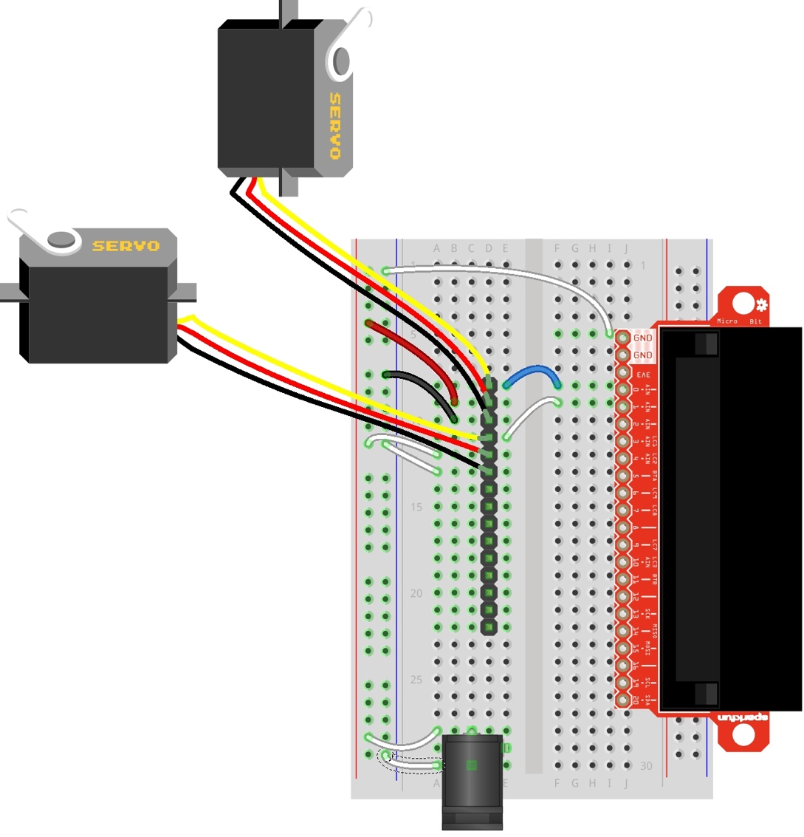

|  |  |  |
| --- | --- | --- |
| **1 |** Grab your second servo. Plug the 3-pin servo cable into the pin header, as shown in the diagram. |  | **2 |** With one of your jumper wires, connect the servo signal wire (yellow or orange wire) to micro:bit **pin 0** as shown in the diagram. |
| **3 |** Connect the servo power wire (red wire) to the breadboard positive power rail. |  | **4 |** Connect the power ground wire (black or brown wire) to the breadboard negative power rail. |

Circuit images made with Fritzing and are licensed for use under CC by SA 3.0. See <http://creativecommons.org/licenses/by-sa/3.0/> for the full description.

Connect articulated fingers to micro:Bit

**Middle finger**

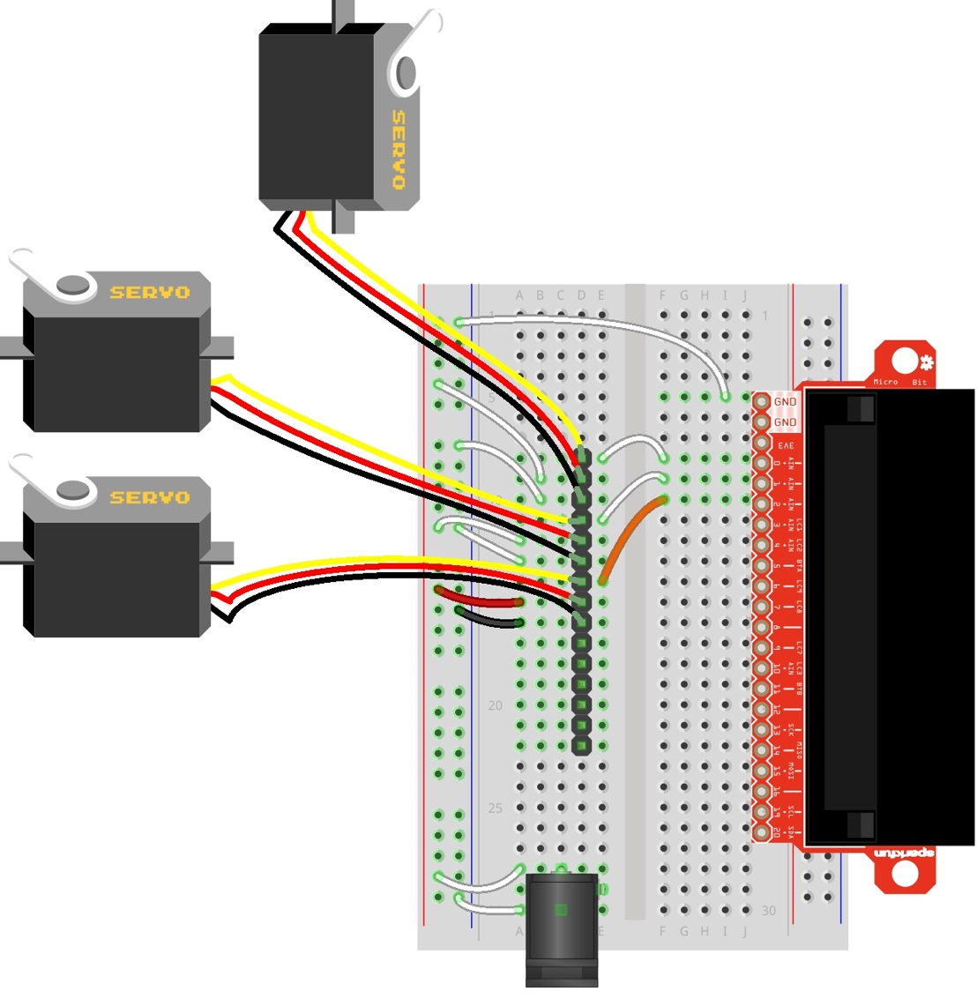

|  |  |  |
| --- | --- | --- |
| **1 |** Grab your third servo. Plug the 3-pin servo cable into the pin header, as shown in the diagram. |  | **2 |** With one of your jumper wires, connect the servo signal wire (yellow or orange wire) to micro:bit **pin 2** as shown in the diagram. |
| **3 |** Connect the servo power wire (red wire) to the breadboard positive power rail. |  | **4 |** Connect the power ground wire (black or brown wire) to the breadboard negative power rail. |

Circuit images made with Fritzing and are licensed for use under CC by SA 3.0. See <http://creativecommons.org/licenses/by-sa/3.0/> for the full description.

Connect articulated fingers to micro:Bit

**Ring finger**

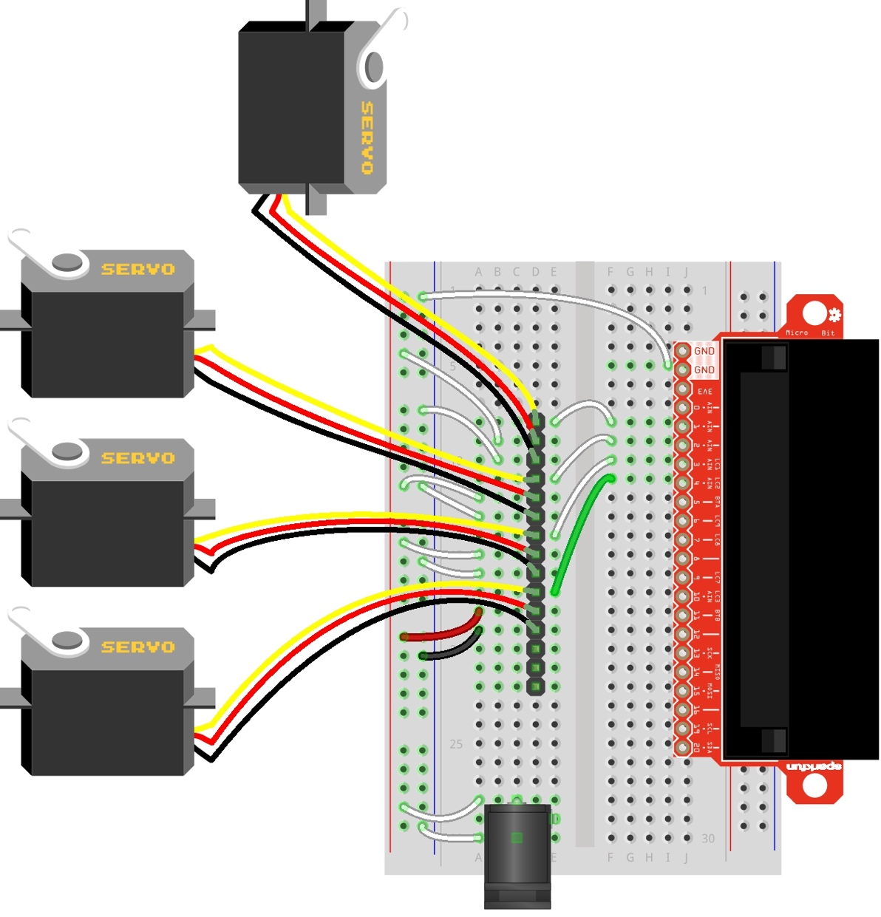

|  |  |  |
| --- | --- | --- |
| **1 |** Grab your fourth servo. Plug the 3-pin servo cable into the pin header, as shown in the diagram. |  | **2 |** With one of your jumper wires, connect the servo signal wire (yellow or orange wire) to micro:bit **pin 3** as shown in the diagram. |
| **3 |** Connect the servo power wire (red wire) to the breadboard positive power rail. |  | **4 |** Connect the power ground wire (black or brown wire) to the breadboard negative power rail. |

Circuit images made with Fritzing and are licensed for use under CC by SA 3.0. See <http://creativecommons.org/licenses/by-sa/3.0/> for the full description.

Connect articulated fingers to micro:Bit

**Pinky finger**

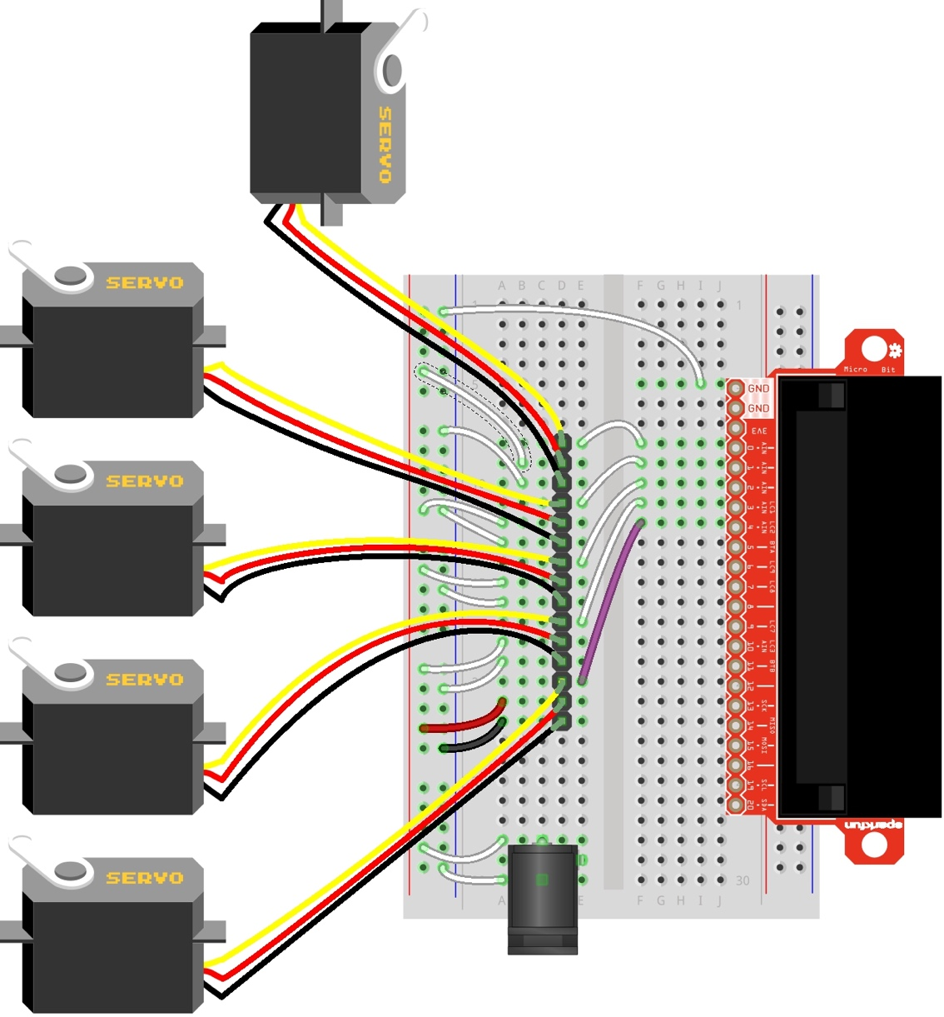

|  |  |  |
| --- | --- | --- |
| **1 |** Grab your fifth servo. Plug the 3-pin servo cable into the pin header, as shown in the diagram. |  | **2 |** With one of your jumper wires, connect the servo signal wire (yellow or orange wire) to micro:bit **pin 4** as shown in the diagram. |
| **3 |** Connect the servo power wire (red wire) to the breadboard positive power rail. |  | **4 |** Connect the power ground wire (black or brown wire) to the breadboard negative power rail. |

Circuit images made with Fritzing and are licensed for use under CC by SA 3.0. See <http://creativecommons.org/licenses/by-sa/3.0/> for the full description.

Test the robotic hand

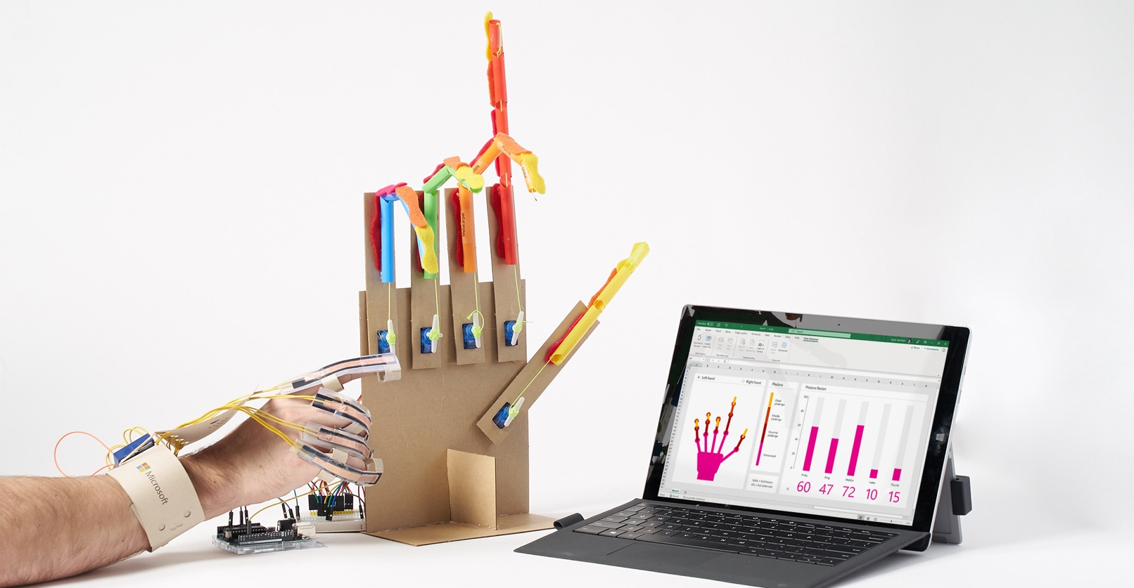

|  |  |  |
| --- | --- | --- |
| **1 |** Plug your external 5V power supply into the breadboard barrel jack and connect it to an electrical outlet. |  | **2 |** Connect your microcontroller to the computer and open the Excel workbook. Navigate to the data streamer tab. |
| **3 |** Start data collection in data streamer. Move the finger sensor(s) to check that it moves the corresponding robotic finger. |  |  |

**TROUBLESHOOTING**

If your servo motor doesn’t work, follow this troubleshooting process.

**Problem -** All flex sensors show -1 on Data In workbook tab.

**Solution** - Flex sensor and servo motor connectors are reversed on the microcontroller. Check the microcontroller pin connections one-by-one.

**Problem -** My sensorized finger doesn’t move on the robotic hand.

**Possible Solutions:**

* Power is not reaching the servo motor. Double check that you have the external power supply plugged in and that the wires are connected correctly as shown in the wiring diagrams.
* The sensor could be faulty in the mechanical finger. If so, remove and replace or acquire one that's working to check that the leads are working.
* The servo motor is fried. Double check that your power supply is 5V and then replace the servo.
* The servo connector is backwards—re-orient the plug connector into the header pins on your breadboard.
* Clear plastic servo arm holding the thread may have fallen off or is loose.
* Make sure that your microcontroller is flashed using the correct code.
* Make sure that you're using the correct Excel Workbook—each Hacking STEM project comes with its own customized workbook.

**Problem -** Excel Round 4 and 5 icons don’t change.

**Solution -** Set Data channels to 22 or higher in the Workbook Settings tab.

**APPENDIX I – SOFTWARE SETUP**

Flash your Arduino Uno

|  |  |  |
| --- | --- | --- |
|  |  |  |
| **1 |** Install the Arduino IDE from the Technical Requirement link on the lesson page at aka.ms/hackingSTEM or through the Microsoft Store. Follow prompts to complete the installation. |  | **2 |** Go to https://aka.ms/biomechanicsarduinocode and download the Arduino code. |
|  |  |  |
|  |  |  |
| **3** | Open your downloaded file to launch the Arduino app. |  | **4** | In the Arduino app, select: Tools > Port > COM 3 (Arduino/Genuino Uno). Your port may be different than COM3. |
|  |  |  |
|  |  |  |
| **5 |** Then select Tools > Board: Arduino/Genuino Uno. |  | **6** | Click on the circular right arrow button to upload. |

Flash your micro:bit

|  |  |  |  |
| --- | --- | --- | --- |
|  |  |  |  |
| **1** | Go to aka.ms/biomechanicsarduinocode to download the first .hex code file that controls the articulated fingers of the robotic hand (File name: microbit_robotic_hand )  ***Note: Remember to download the second code and flash your second micro:bit!*** |  |  | **2** | Plug your micro:bit to your computer using a USB cable. [Install the mbed driver](https://os.mbed.com/docs/v5.9/tutorials/windows-serial-driver.html). If you’ve done this before, you won’t have to do it again. |
|  |  |  |  |
| **3** | In File Explorer, navigate to the micro:bit. It will appear like an external storage device (e.g. thumb drive, hard drive, etc.). |  |  | **4** | Open a second File Explorer window and navigate to the downloads folder. Make sure you can see both windows. |
|  |  |  |  |
| **5** | Select the .hex file in downloads and drag it to the micro:bit window. |  |  | **6** | Once the LED light stops blinking, the code has been uploaded onto the micro:bit. **Repeat Steps 1 - 6 for your second micro:bit** that reads in the flex finger sensors in the glove controller. This code can be found here: aka.ms/biomechanicsarduinocode (File name: microbit_robotic_hand_glove). |

Enable Data Streamer in Excel

Data Streamer with Excel O365. The O365 subscription includes Excel and the Data Streamer add-in for free.

|  |  |  |
| --- | --- | --- |
|  |  |  |
| **1** | Open Excel 0365. |  | **2** | Click on **File** and choose **Options** located at the bottom of the pane. |
|  |  |  |
| **3** | Choose **Add-ins** in the dialog that opens. |  | **4** | From the **Manage** menu at the bottom of the dialog that opens, choose **COM Add-Ins** and click **Go.** |
|  |  |  |
| **5** | Check the box for **Microsoft Data Streamer**  in the dialog that opens and click **OK.** |  | **6** | You should see a new Data Streamer tab in Excel’s menu ribbon. |

**Data Streamer with Excel O365 desktop version**

For a limited time, Data Streamer can be used with the desktop version of Excel 2016. Download Data Streamer from the Microsoft Store. After installation, Data Streamer will be automatically enabled in Excel.

Using Data Streamer

**To run the Data Streamer Add-in, make sure you meet these technical requirements:**

* PC running Windows 10 and Excel O365 Desktop.
* Enable the Data Streamer add-in. See instructions on previous page.
* Customized Excel Workbook available at: aka.ms/biomechanicsworkbook.

Congratulations! You are now ready to visualize real-time data from the finger sensors. To see live data, follow these steps:

|  |  |  |
| --- | --- | --- |
| **1** | Plug the Arduino microcontroller into your computer’s USB port. |  | **2** | Click the **Data Streamer** tab on the Excel ribbon. |
| **3** | Click **Connect a Device** to connect Excel to the microcontroller. |  | **4** | Start Data to begin streaming data into Excel, |
|  |  |  |
|  |  |  |

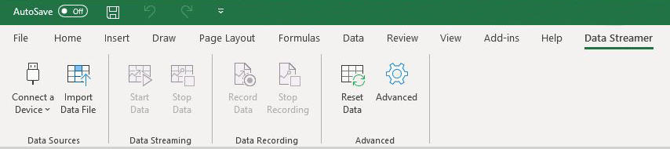

To connect your device, plug it into your computer via USB and then click “Connect a Device.”

Once your device is connected, select “Start Data” to begin streaming data into Excel. If you do not click “Start Data” when your device is plugged in, you will not see any live data.

If you have recorded and saved a data file (.csv), you can import it with this button

**APPENDIX II TROUBLESHOOTING**

**TROUBLESHOOTING THE FINGER FLEX SENSORS**

**Problem:** The corresponding finger in the Excel simulation does not move or moves randomly.

**Possible Solutions**:

* The sensor readings take some time to settle. Wait for a few seconds and then retry.
* Double check the finger sensor connections to your microcontroller.
  + Arduino connections: The index finger connects to analog pin A1, the thumb to A0, middle finger to A2, ring finger to A3, and pinky finger to A4.
  + micro:bit connections: The index finger connects to pin 1, the thumb to 0, middle finger to 2, ring finger to 3, and pinky finger to 4.
* Check that the microcontroller is plugged in and the appropriate code successfully uploaded to the board.
* The sensor could be faulty in the glove. If so, remove and replace or acquire one that's working to check that the leads are properly connected.
* Make sure that you're using the correct Excel Workbook—each Hacking STEM project comes with its own customized workbook.

*Still not working? Ask a classmate, your teacher, or reach out to us at: aka.ms/hackingSTEM*

**TROUBLESHOOTING THE ARTICULATED FINGERS**

**Problem -** All flex sensors show -1 on Data In workbook tab.

**Solution** - Flex sensor and servo motor connectors are reversed on the microcontroller. Check the microcontroller pin connections one-by-one.

**Problem -** My sensorized finger doesn’t move on the robotic hand.

**Possible Solutions:**

* Power is not reaching the servo motor. Double check that you have the external power supply plugged in and that the wires are connected correctly as shown in the wiring diagrams.
* The sensor could be faulty in the glove. If so, remove and replace or acquire one that's working to check that the leads are working.
* The servo motor is fried. Double check that your power supply is 5V and then replace the servo.
* The servo connector is backwards—re-orient the plug connector into the header pins on your breadboard.
* Clear plastic servo arm holding the thread may have fallen off or is loose.
* Make sure that your microcontroller is flashed using the correct code.
* Make sure that you're using the correct Excel Workbook—each Hacking STEM project comes with its own customized workbook.

**Problem -** Excel Round 4 and 5 icons don’t change.

**Solution -** Set Data channels to 22 or higher in the Workbook Settings tab.

**APPENDIX III - EXTENSIONS**

Rock, Paper, Scissors Extension

With your glove connected to the Data Streamer Add-in, you can play Rock, Paper, Scissors (RPS) with Excel.

**Game Basics**

The sensor-enabled glove you have created and connected to the Excel worksheet can be found on the left side of the worksheet while Excel’s hand gestures are represented on the right. An RPS match will consist of 5 rounds. In each round, you will see the message sequence “Ready”, “Set”, “GO!” When “GO!” appears, throw your RPS gesture.

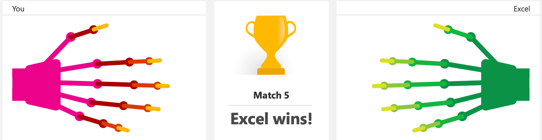

**RPS game history**

The rounds will be shown below the hand visualization while the match number can be found in between the two hand visualizations. (Note: if your gesture cannot be determined, the round will end as a tie). The history of the gestures thrown in the current match’s rounds can be seen below the main hand diagram areas. After 5 rounds, the winner of the match will be the player (you or Excel) with more round wins. Details on prior matches are also available at the bottom of the worksheet.

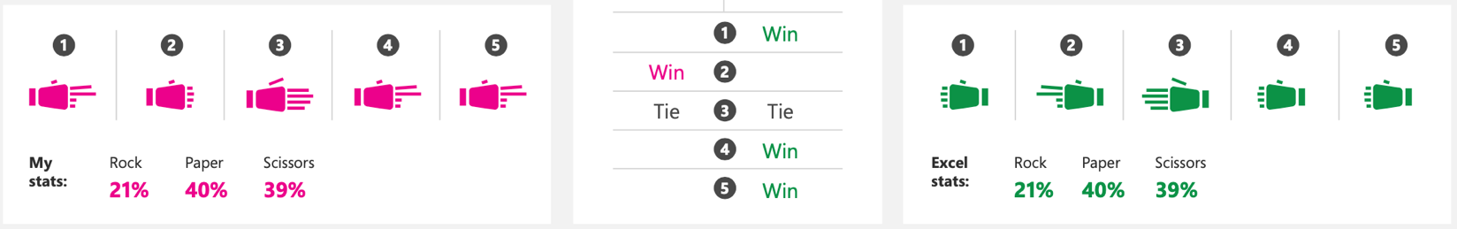

**APPENDIX IV – TEMPLATES**

Page Intentionally left blank



Page Intentionally left blank

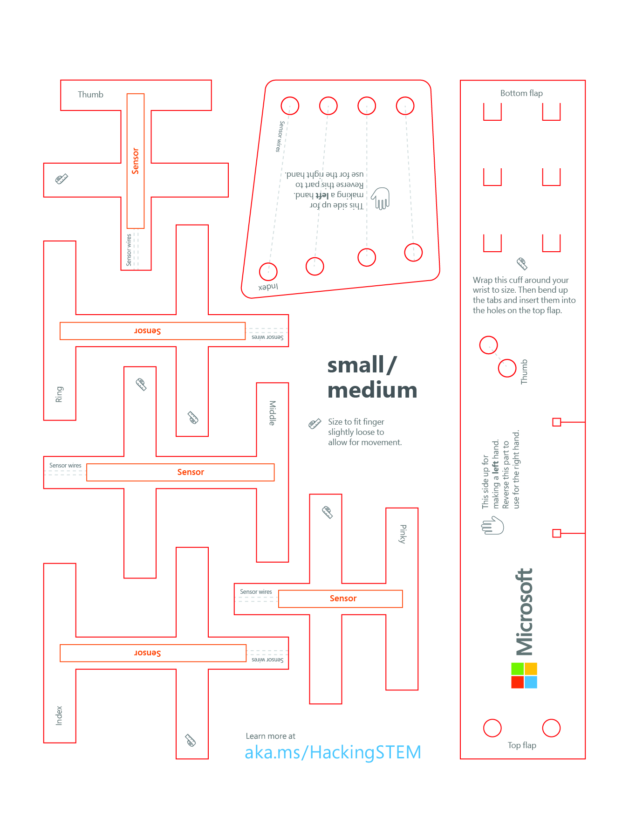

Page Intentionally left blank

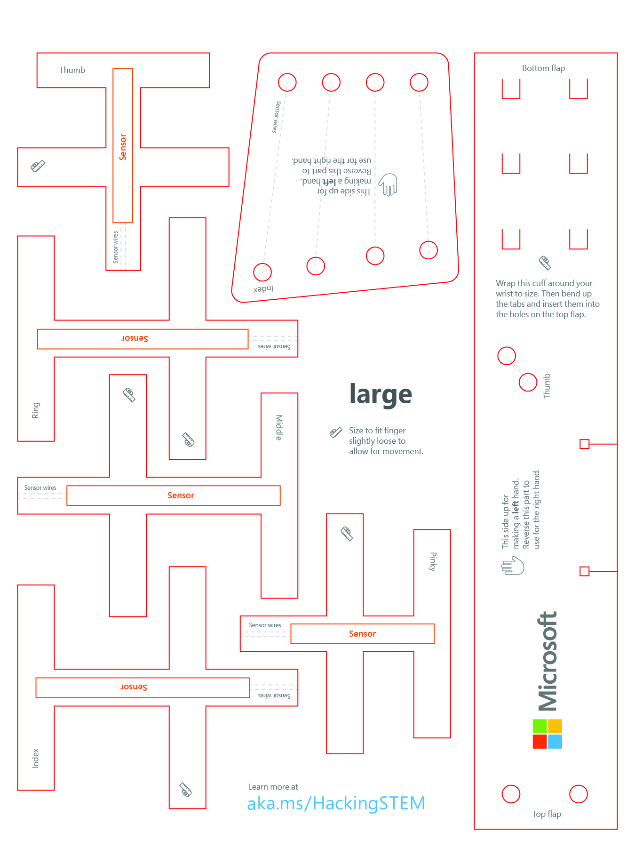

Page Intentionally left blank



Page Intentionally left blank

